International Economics, 10e (Krugman/Obstfeld/Melitz)
Chapter 20 (9) Financial Globalization: Opportunity and Crisis

20.1 The International Capital Market and the Gains from Trade

1) If you are offered a gamble in which you win 500 dollars 3/8 of the time and you lose 500 dollars 5/8 of the time, what is your expected payoff and your behavior given that you are a risk-lover?
A) $500, take the gamble
B) -$125, take the gamble
C) -$125, it is unclear what you would do without further information
D) $500, decline the gamble
E) -$125, decline the gamble
Answer: C
Page Ref: 597-602
Difficulty: Easy

2) The two types of trade, intertemporal and pure asset swap ________ perfect substitutes, because ________.
A) are; they both offer considerable payoff and are equal in the long run
B) are; they both involve the smoothing out of now and future consumption
C) are not; asset swapping is immediate and involves only assets, while intertemporal trade takes two time periods and involves both assets and goods/services
D) could possibly be; different economic states occur at different points in time
E) are not; asset swapping never relates to intertemporal trade
Answer: D
Page Ref: 597-602
Difficulty: Easy

3) For the following question assume the following facts:
(1) Balance of Payments = 0 prior to the transactions.
(2) Person A (who lives in the United States) purchases an airplane from British Airways for $150,000.
(3) Person A pays with a check from his account at First Union Bank in the United States.
(4) British airways, since it will need dollars in 1 month, deposits the check at the Bank of England.
(5) Bank of England deposits the $150,000 at Commonwealth bank, which is located in the United States.
Due to the transactions above, what are the effects on the balance of payments?
A) -$150,000 due to import of good (current account debit)
B) +$150,000 due to import of good (current account credit)
C) -$150,000 due to deposit of Bank of England (capital account debit)
D) +$150,000 due to deposit of Bank of England (capital account credit)
E) No effect (150,000 current account debit and 150,000 capital account credit)
Answer: E
Page Ref: 597-602
Difficulty: Easy
4) For the following questions assume the following facts:
(1) Balance of Payments = 0 prior to the transactions.
(2) Person A (who lives in the United States) purchases an airplane from British Airways for $150,000.
(3) Person A pays with a check from his account at First Union Bank in the United States.
(4) British airways, since it will need dollars in 1 month, deposits the check at the Bank of England.
(5) Bank of England deposits the $150,000 at Commonwealth bank, which is located in the United States.
Due to the transactions above, what are the effects on the reserve at the Fed?
A) Fact 2 is a decrease of $150,000, fact 5 is a decrease of $150,000, a net effect of -$300,000.
B) Fact 3 is a decrease of $150,000, fact 5 is an increase of $150,000, a net effect of 0.
C) Fact 3 is an increase of $150,000, fact 5 is a decrease of $150,000, a net effect of 0.
D) Both fact 3 and fact 5 result in increases of $150,000, a net effect of +$300,000.
E) Both fact 3 and fact 5 result in decrease of $150,000, a net effect of -$300,000.
Answer: B
Page Ref: 597-602
Difficulty: Easy

5) Suppose one is offered a gamble in which you win $1,000 half the time but lose $1,000 half the time. Since in this case one is as likely to win as to lose the $1,000, the average payoff on this gamble—its expected value—is:
0.5 ∗ $1,000 + 0.5 ∗ (-$1,000) = 0.
Under such circumstances:
A) no one will take the gamble.
B) risk averse individuals will take the gamble.
C) risk lovers individuals will not take the gamble.
D) risk neutral individuals will not take the gamble.
E) risk lovers and risk neutral individuals may take the gamble.
Answer: E
Page Ref: 597-602
Difficulty: Easy

6) For most practical matters, economists assume that
A) individuals are risk neutral.
B) individuals are risk lovers.
C) individuals are risk averse.
D) most individuals are risk lovers.
E) most individuals are risk neutral.
Answer: C
Page Ref: 597-602
Difficulty: Easy
7) People who are risk averse
A) value a collection of assets only on the basis of its expected returns.
B) value a collection of assets only on the basis of the risk of that return.
C) value a collection of assets not only on the basis of its expected returns but also on the basis of the risk of that return.
D) are less likely to invest in life insurance.
E) are less likely to have a diverse portfolio.
Answer: C
Page Ref: 597-602
Difficulty: Easy

8) The idea of risk aversion
A) is at odds with the idea of insurance.
B) help explain the profitability of insurance companies.
C) has nothing to do with insurance companies.
D) help explain the losses suffers by the insurance industry.
E) help explain why insurance companies in the long run are zero profit companies.
Answer: B
Page Ref: 597-602
Difficulty: Easy

9) Risk averse people
A) will never hold bonds denominated in several different currencies because of transaction costs.
B) will always hold bonds denominated in several different currencies because of transaction costs.
C) may hold bonds denominated in several different currencies.
D) may hold bonds denominated in several different currencies only if satisfying the well known interest party condition.
E) will hold only domestic bonds because of the home bias effect.
Answer: C
Page Ref: 597-602
Difficulty: Easy

10) Imagine that there are two countries, Home and Far Far Away, and that residents of each own only one asset, domestic land yielding an annual harvest of mangoes. Assume that the yield on the land is uncertain. Half the time, Home's land yields a harvest of 5,000 tons of mangoes at the same time as Far Far Away's land yields a harvest of 2,500 tons. The other half of the time the outcomes are reversed. The average for each country mango harvest is
A) 2500.
B) 2750.
C) 3500.
D) 3750.
E) 3000.
Answer: D
Page Ref: 597-602
Difficulty: Easy
11) Equity Instruments include
A) stocks.
B) bonds.
C) banks deposits.
D) receipts.
E) bank statements.
Answer: A
Page Ref: 597-602
Difficulty: Easy

12) What would best describe the international capital markets?
A) the market of exchange of bonds
B) the market of exchange of stocks
C) the market of exchange of real-estate
D) the market in which residents of different countries trade assets
E) the currency market
Answer: D
Page Ref: 597-602
Difficulty: Easy

13) Describe three types of gains from trades?
A) trades of exchange rates for goods or services, trades of goods or services for property, and trades of gold for textiles
B) trades of goods or services for goods or services, trades of goods or services for assets, and trades of assets for assets
C) trades of imports for exports, trades of exports for imports, and trades of natural resources for financial assets
D) trades of services for goods, trades of currency for services, and trades of one type of currency for another
E) trades of current goods for future services, trades of currency for gold, and trades of one type of currency for another
Answer: B
Page Ref: 597-602
Difficulty: Easy

14) Asset trades that deal with debt instruments are best described as
A) share of stock.
B) exchange rate.
C) receipts.
D) factors.
E) bonds or bank deposits.
Answer: E
Page Ref: 597-602
Difficulty: Easy
15) Asset trades that deal with equity instruments are best described as
A) share of stock.
B) exchange rate.
C) bonds.
D) bank deposits.
E) factors.
Answer: A
Page Ref: 597-602
Difficulty: Easy

16) The international capital market is:
A) the international currency exchange.
B) a market in which capital assets are exchanged for services.
C) the market that is subject to intense regulation and must file a report to the Basel committee on a biannual basis.
D) not really a single market, but a group of closely interconnected markets in which asset exchanges with some international dimension take place.
E) an organization of fiscal policies that dictate international trade.
Answer: D
Page Ref: 597-602
Difficulty: Easy

17) Intertemporal trade is
A) the exchange of goods but not services for claims to future goods.
B) the exchange of services but not goods for claims to future services.
C) the exchange of good and services for claims to future goods and services.
D) the exchange of domestic goods and services for foreign goods and services.
E) the type of trade that the U.S. government focuses most upon.
Answer: C
Page Ref: 597-602
Difficulty: Easy

18) What is the basic motive for asset trade?
A) the belief that large risks will lead to large returns
B) restoration of the balance of payments
C) portfolio unification
D) economic stability
E) increase expected returns and reduced risk
Answer: E
Page Ref: 597-602
Difficulty: Easy

19) Using international asset trade, countries can
A) never really eliminate all risk.
B) eliminate all risk.
C) actually increase their risk in some cases.
D) eliminate all their risk except for emerging markets.
E) never really diversify their holdings.
Answer: A
Page Ref: 597-602
Difficulty: Easy
20) What are the three types of transactions between the residents of different countries?
Answer: The three types are:
(1) Trades of goods and services for goods or services
(2) Trades of goods and services for assets, and
(3) Trades of assets for assets.
Page Ref: 597-602
Difficulty: Moderate

21) What are the three types of gains from international transactions between the residents of different countries?
Answer: The three types are:
(1) Gains due to comparative advantage and economies of scale.
(2) Gains due to inter-temporal trade, which is the exchange of goods and services for claims to future goods and services, which is for assets.
(3) Gains due to trades of assets for assets, such as the exchange of real estate located in London for U.S. Treasury bonds.
Page Ref: 597-602
Difficulty: Moderate

22) How international trade in assets can make both countries better off?
Answer: By allowing them to reduce the riskiness of the return on their wealth and by allowing the two parties to diversify their portfolios, i.e., to divide their wealth among a wider spectrum of assets, and thus reduce the amount of money placed on one specific asset.
Page Ref: 597-602
Difficulty: Moderate

23) Explain Tobin's idea of "Don't put all your eggs in one basket."
Answer: Trade in assets can make both parties better off by allowing them to reduce the riskiness of the return on their wealth. Portfolio diversification occurs when the wealth is divided among a wide spectrum of assets, so the amount of money riding on each individual asset is reduced. Obviously, this diversification needs to be contrasted against the expected returns of the new assets that you are acquiring.
Page Ref: 597-602
Difficulty: Moderate

24) Why is it useful to make a distinction between debt and equity instruments?
Answer: Debt instruments such as bonds and bank deposits are repaid regardless of economic circumstances. Equity instruments, like a share of stock, have a payoff that is linked to economic performances. However, remember the possibility of bankruptcy and the real return, which is subject to domestic currency fluctuations.
Page Ref: 597-602
Difficulty: Moderate

25) Define risk aversion and give an example of a risk-averse person?
Answer: Risk aversion is a characteristic of a person that dislikes risk. An example of this is someone who takes out rental or home insurance to reduce the risk of some kind of catastrophe from happening.
Page Ref: 597-602
Difficulty: Moderate
26) Why is portfolio diversification so important in international trade?
Answer: Portfolio diversification is important in international trade because parties of the trade are better off by allowing themselves to reduce the risk of the return on their wealth. Traders can divide their wealth among wider amounts of assets in turn reducing the amount of money they have riding on each individual asset.
Page Ref: 597-602
Difficulty: Moderate

27) What is the difference between equity instruments and debt instruments?
Answer: Equity instruments are share of stocks. It is defined as a claim to the firm's profit. Debt instrument are bonds and bank deposits. They specify that the issuer of the instrument must repay a fixed value.
Page Ref: 597-602
Difficulty: Moderate

28) Why is the foreign exchange market so vital?
Answer: The foreign exchange market is the central component of the international capital market. The exchange rates it sets help determine the profitability of international transactions of all type. The exchange rates show valuable economic signals to households and firms involved in international trade and investment.
Page Ref: 597-602
Difficulty: Moderate

29) Suppose you are offered a gamble in which you win $1,000 half the time but lose $1,000 half the time. If you are risk averter will you take the gamble?
Answer: Since you are as likely to win as to lose the $1,000, the average payoff on this gamble—its expected value— is:
0.5 ∗ $1,000 + 0.5 ∗ (-$1,000) = 0. If you are risk averse, you will not take the gamble because, for you, the possibility of losing $1000 outweighs the possibility that you will win, although both outcomes are equally likely.
Page Ref: 597-602
Difficulty: Moderate

30) Suppose you are offered a gamble in which you win $1,000 1/3 half the time but lose $800 2/3 half the time. If you are risk lover will you take the gamble? What will your expected payoff be?
Answer: The expected payoff would be:
1/3 (+$1,000) + 2/3 (-$800) = -$200.
From this calculation, we know that risk-neutral individuals would not take the gamble, but it is not clear what a risk-loving individual would do.
Page Ref: 597-602
Difficulty: Moderate
31) Calculate the expected payoff for the following cases, where q1 and q2 are the probabilities of state 1 and 2, respectively.

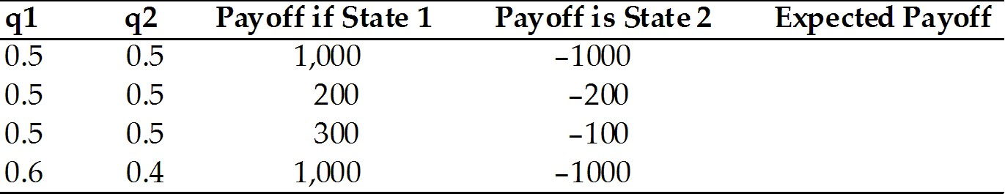
Answer:
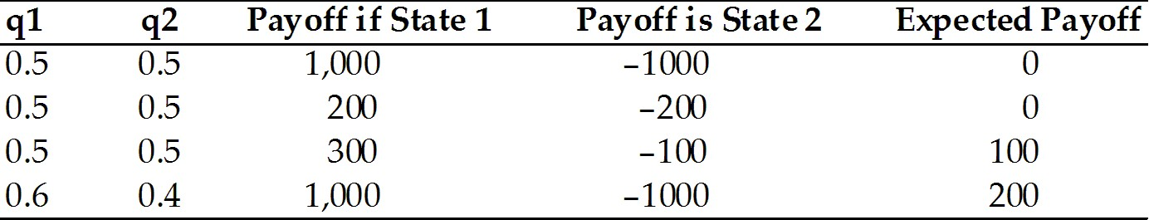
Page Ref: 597-602
Difficulty: Moderate

32) Calculate the expected payoff for the following cases, where q1 and q2 are the probabilities of state 1 and 2, respectively.

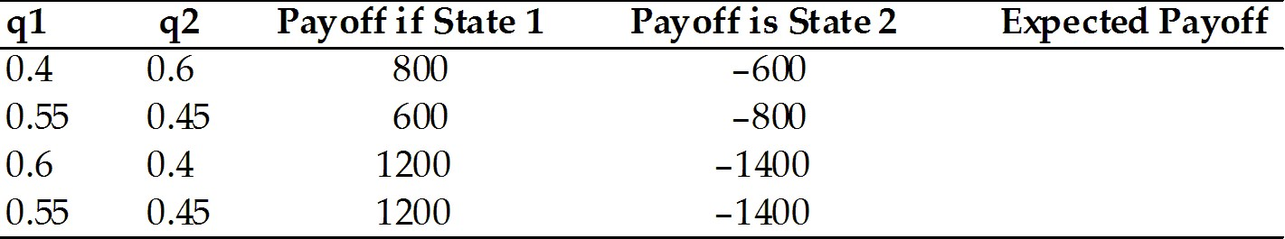
Answer:
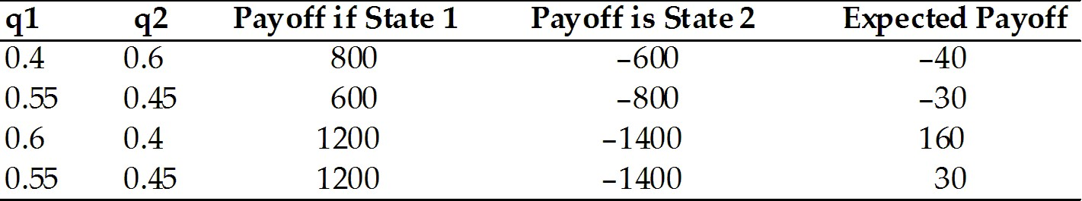
Page Ref: 597-602
Difficulty: Moderate
33) Complete the following table.

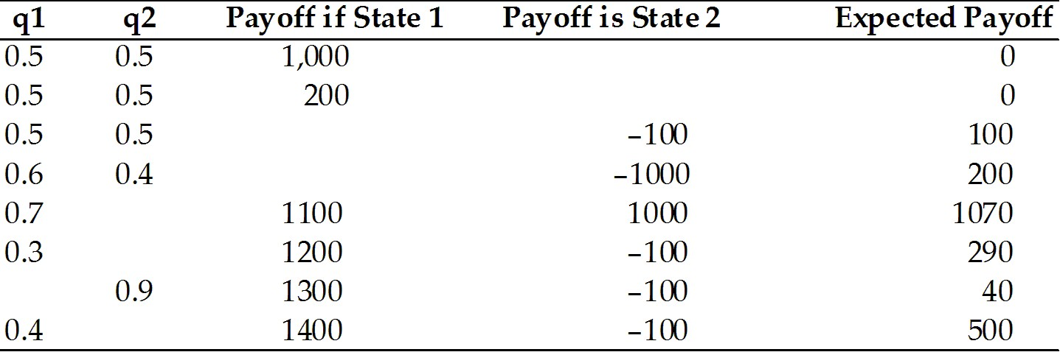
Answer:
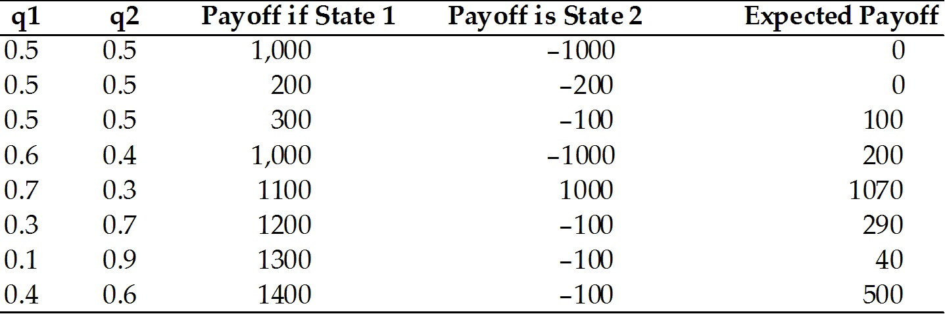
Page Ref: 597-602
Difficulty: Moderate

34) Complete the following table.

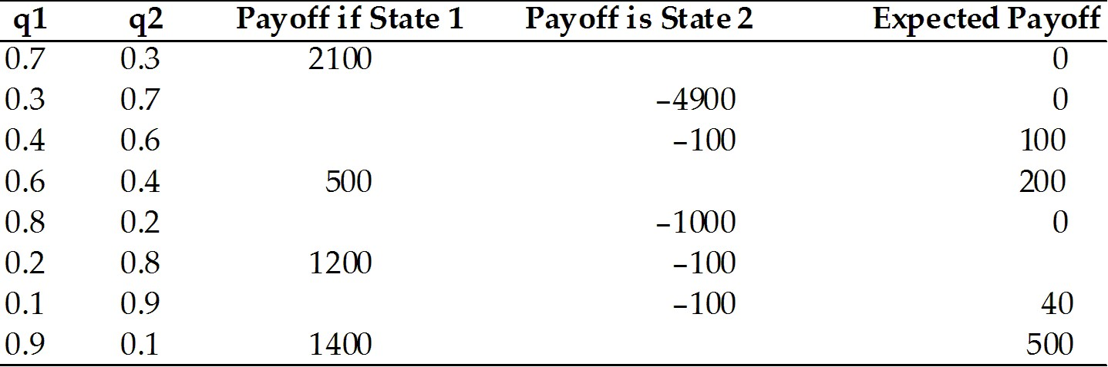
Answer:
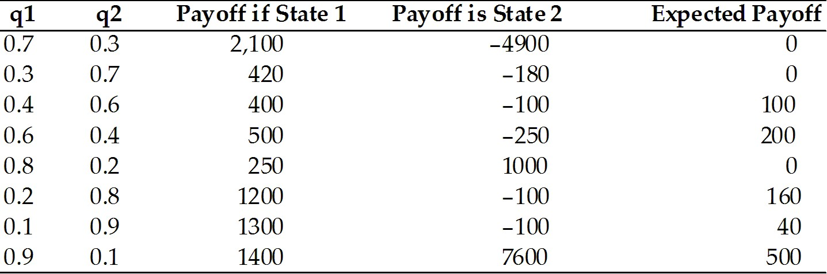
Page Ref: 597-602
Difficulty: Moderate
The following simple two-country question illustrates how countries are made better off by trade in assets. Imagine that there are two countries, Home and Foreign, and that residents of each own only one asset, domestic land yielding an annual harvest of kiwi fruit. Assume that the yield on the land is uncertain. Half the time, Home's land yields a harvest of 100 tons of kiwi fruit at the same time as Foreign's land yields a harvest of 50 tons. The other half of the time the outcomes are reversed. The Foreign's harvest is 100 tons, but the Home harvest is only 50.

35) Calculate the average, for each country of kiwi harvest.
Answer: The average for each country of kiwi harvest is: 0.5 ∗ 100 + 0.5 ∗ 50 = 75 tons of kiwi fruit. However, note that the inhabitants of the two countries never know in advance whether the next year will bring feast or famine.
Page Ref: 597-602
Difficulty: Difficult

36) Suppose the two countries can trade shares in the ownership of their perspective assets. Further, assume that a Home owner of a 10 percent share in Foreign land. He will receive 10 percent share in Foreign land, and thus receives 10 percent of the annual Foreign kiwi fruit harvest. Further assume that a Foreign owner of a 10 percent share in Home land is permitted. In this case, a Foreigner is entitled to 10 percent of the Home harvest. Calculate the expected value of kiwi fruit for each investor. Is the investor better off?
Answer: Good year at Home: the farmer will get 90 toms of kiwi from home and 5 tons of kiwi from Foreign. Bad years at home: he will get 45 tons of kiwi from his Home and 10 tons from the Foreign country, namely 55 tons. The probability for a good or a bad year is 0.5. Thus the expected returns will now be:
0.5 ∗ 95 + 0.5 ∗ 55 = 75
It is not clear whether the investor is better off or not. If he likes to smooth his consumption, he may be better off. Otherwise, it is impossible to tell without a particular utility function.
Page Ref: 597-602
Difficulty: Difficult

37) Suppose the two countries can trade shares in the ownership of their perspective assets. Further assume that a Home owner of a 25 percent share in Foreign land. He will receive 25 percent share in Foreign land and thus receives 25 percent of the annual Foreign kiwi fruit harvest. Further assume that also that a Foreign owner of a 25 percent share in Home land is permitted. In this case, a Foreigner is entitled to 25 percent of the Home harvest. Calculate the expected value of kiwi fruit for each investor.
Answer: Good year at Home: 75 + 12.5 = 87.5 tons with probability 0.5
Bad year at Home: 37.5 from Home and 25 from Foreign = 62.5 with probability 0.5.
The expected return is: 0.5 ∗ 87.5 + 0.5 ∗ 62.5 = 75.
Page Ref: 597-602
Difficulty: Difficult
38) Suppose the two countries can trade shares in the ownership of their perspective assets without any restrictions. Assume that the consumers in both countries would like to totally smooth their consumption. Describe the outcomes.
Answer: In this case, Home residents will buy a 50 percent share of the land in Foreign, and they will pay for it by giving Foreign residents a 50 percent share in Home land. Explain why. To understand why, think about the returns to the Home and Foreign portfolios when both are equally divided between titles to Home and Foreign land. When times are good at Home (and therefore bad in Foreign), each country earns the same return harvest, which is 75 every year with certainty.
Half of the Home harvest (100 ton of kiwi fruit) plus half of the Foreign harvest (50 tons of kiwi fruit) or 75 tons of fruit.
0.5 ∗ 100 + 0.5 ∗ 500 = 75.
In the opposite case-bad times in Home, good time in Foreign-each country still earns 75 tons of fruit.
Thus, we have shown that if the countries hold portfolios equally divided between the two assets, each country earns a certain return of 75 tons of kiwi fruit. This certain return is exactly the same as the average harvest each faced before international asset trade was allowed. This trade completely eliminates the risk faced by both countries without changing average returns. Assuming risk-averse individuals in both countries, the two countries are better off as a result of asset trade.
Page Ref: 597-602
Difficulty: Difficult

39) Suppose that trade in asset is not allowed but the two countries sign a treaty that guarantee the sending of 25 tons of kiwi in good time by the high output country in that season. What will the outcome of such a treaty? Explain why.
Answer: The outcomes will be exactly the same as in Case D above. In other words, rather than signing a treaty, just leaving the financial markets to function will lead us to the desirable results.
Page Ref: 597-602
Difficulty: Difficult
40) Calculate the expected payoff for the following cases with the formula: (P1) * (payoff if state 1) + (P2) * (payoff if state 2), where P1 and P2 are the probabilities of state 1 and 2, respectively.

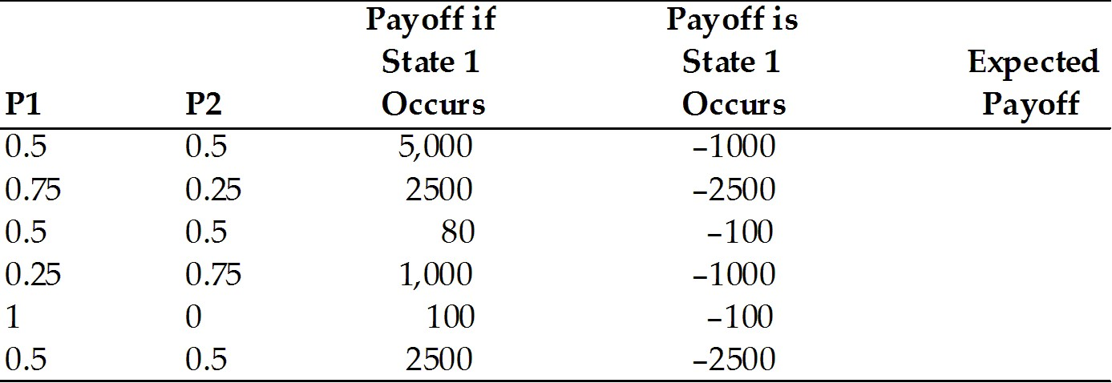
Answer:
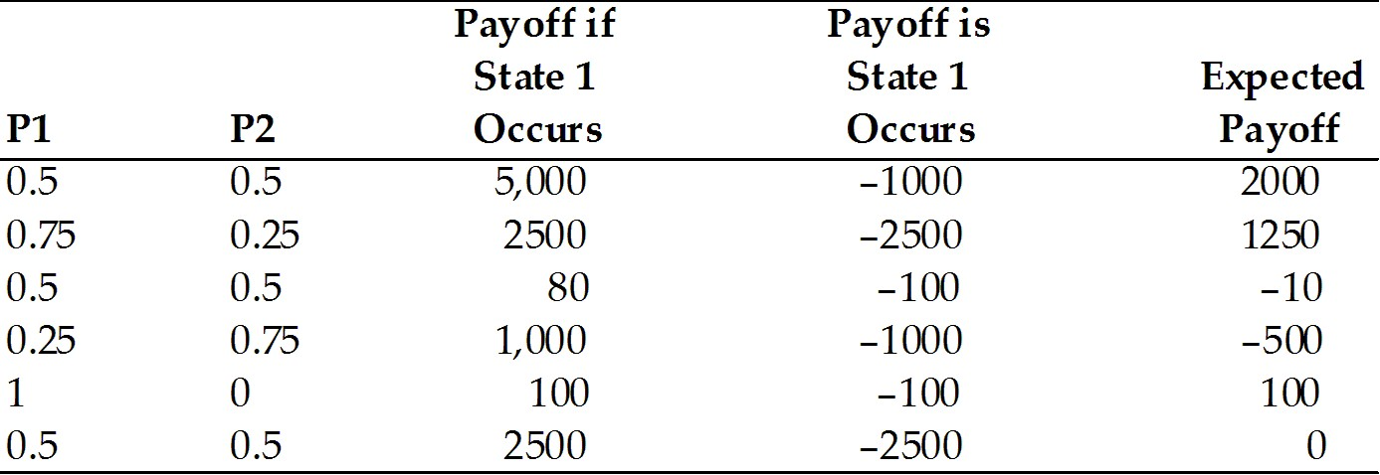
Page Ref: 597-602
Difficulty: Moderate
41) Complete the following table with the formula (P1) * (payoff if state 1) + (P2)* (payoff if state 2), where P1 and P2 are the probabilities of state 1 and 2, respectively.

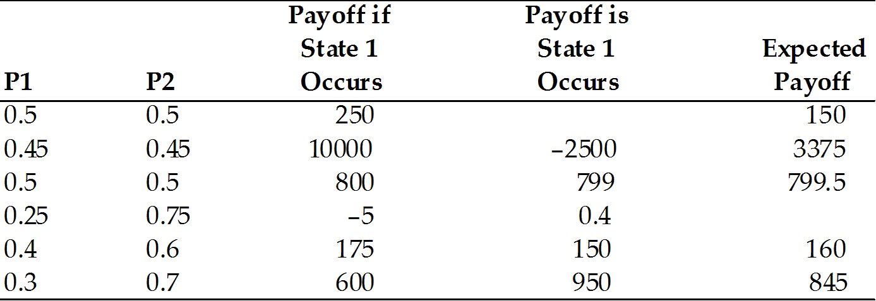
Answer:
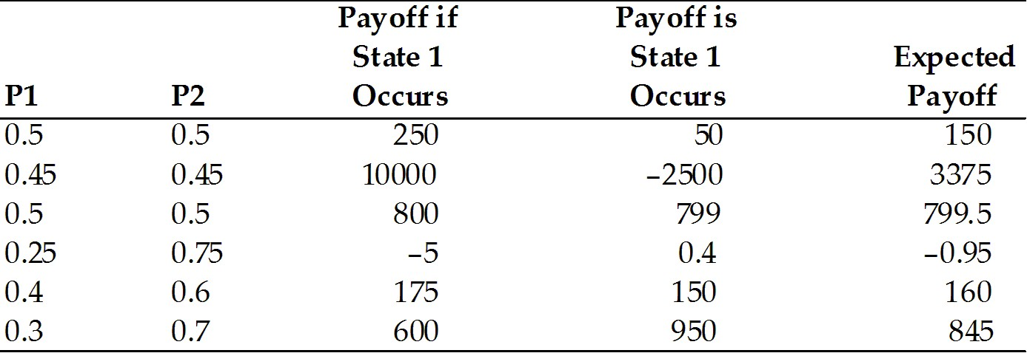

Page Ref: 597-602
Difficulty: Moderate

20.2 International Banking and the International Capital Market

1) As a country begins to liberalize its capital account, what would you expect to happen to the difference between the interest rates for similar assets in this country and another country with open capital markets?
A) get larger
B) get smaller
C) stay the same
D) it depends on the existing exchange rate.
E) exponential divergence
Answer: B
Page Ref: 602-605
Difficulty: Easy

2) Investment banks in the U.S. are
A) regular banks specializing in investment projects.
B) not banks at all but institutions which specialize in underwriting sales of stocks and bonds.
C) special arm of the U.S. government for U.S. banks operating outside the U.S.
D) regular banks specializing in investment projects, but allowed to offer limited domestic transactions.
E) international banks that are heavily invest in the U.S.
Answer: B
Page Ref: 602-605
Difficulty: Easy
3) Credit Suisse, Goldman Sachs, and Lazard Freres are examples of
A) commercial banks.
B) corporations.
C) non-bank financial institutions, such as insurance companies, pension funds, and mutual funds. This includes investment banks, which specialize in underwriting sales of stocks and bonds by corporations and in some cases governments.
D) central banks and other government agencies.
E) non-profit organizations.
Answer: C
Page Ref: 602-605
Difficulty: Easy

4) A country can control
A) its flexible exchange rate.
B) monetary policy oriented toward domestic goals.
C) international capital movements.
D) foreign inflationary policies.
E) and avoid risks in international trade.
Answer: B
Page Ref: 602-605
Difficulty: Easy

5) Under a gold standard, countries control
A) its flexible exchange rate.
B) monetary policy oriented toward domestic goals.
C) international capital movements.
D) foreign inflationary policies.
E) and avoid risks in international trade.
Answer: B
Page Ref: 602-605
Difficulty: Easy

6) After Bretton Woods period, countries chose to control
A) fixed exchange rate only.
B) monetary policy oriented toward domestic goals only.
C) freedom of international capital movements only.
D) fixed exchange rate and freedom of international capital movements.
E) fixed exchange rate and monetary policy oriented toward domestic goals.
Answer: D
Page Ref: 602-605
Difficulty: Easy

7) Under the unified Euro regime, the European countries control
A) fixed exchange rate only.
B) monetary policy oriented toward domestic goals only.
C) freedom of international capital movements only.
D) monetary policy oriented toward domestic goals and freedom of international capital movements.
E) fixed exchange rate and freedom of international capital movements.
Answer: E
Page Ref: 602-605
Difficulty: Easy
8) Which one of the following possibilities is TRUE?
A) Much of eurocurrency trading occurs in Europe.
B) Much of eurocurrency trading occurs in the United States.
C) Eurocurrencies trading occurs everywhere except the United States.
D) Eurocurrencies trading occurs everywhere except Europe.
E) Eurocurrencies trading occurs everywhere except China.
Answer: C
Page Ref: 602-605
Difficulty: Easy

9) Eurodollars are
A) dollar deposits located in the United States.
B) dollar deposits located in Europe.
C) dollar deposits located outside Europe.
D) dollar deposits located outside the United States.
E) dollar deposits located outside both Europe and the United States.
Answer: D
Page Ref: 602-605
Difficulty: Easy

10) Eurobanks are
A) all European Banks.
B) all non American banks.
C) banks that accept deposits denominated in Eurocurrencies excluding Eurodollars.
D) banks that accept deposits denominated in Eurocurrencies including Eurodollars.
E) banks that do not take U.S. dollars.
Answer: D
Page Ref: 602-605
Difficulty: Easy

11) The leading center of Eurocurrency trading is
A) New York City.
B) Chicago.
C) London.
D) Paris.
E) Frankfurt.
Answer: C
Page Ref: 602-605
Difficulty: Easy

12) The Fed's Regulation Q
A) placed a ceiling on the interest rates U.S. banks could pay on time deposits to foreigners.
B) placed a ceiling on the interest rates U.S. banks could pay on time deposits.
C) placed a ceiling on the amount U.S. residents can deposits in Euro banks.
D) placed a ceiling on the amount foreign residents can deposits in domestic American banks.
E) placed a ceiling on the amount foreign banks can pay on time deposits.
Answer: B
Page Ref: 602-605
Difficulty: Easy
13) Which type of main institution in the international capital market most often is involved in foreign exchange intervention?
A) central banks
B) non-bank financial institutions
C) insurance companies
D) corporations
E) commercial banks
Answer: A
Page Ref: 602-605
Difficulty: Easy

14) The difference between an agency office located abroad and a subsidiary bank located abroad is
A) an agency office is just a home bank in another country while a subsidiary bank is controlled by a foreign bank and subject to the same regulations as local banks.
B) an agency office is just a home bank in another country while a subsidiary bank arranges loans and transfers funds but does not accept deposits.
C) an agency office arranges loans and transfers funds but does not accept deposits while a subsidiary bank is controlled by a foreign bank and subject to the same regulations as local banks.
D) an agency office arranges loans and transfers funds but does not accept deposits while a subsidiary bank is just a home bank in a foreign country.
E) an agency office is controlled by a foreign bank and subject to the same regulations as local banks while a subsidiary bank arranges loans and transfers funds but does not accept deposits.
Answer: C
Page Ref: 602-605
Difficulty: Easy

15) Besides world trade growth, what can explain the growth of international banking since the 1960s?
A) war in the Middle East
B) government focus on banking regulation.
C) an increase in world travel.
D) the emergence of developing countries like China.
E) desire of depositors to hold currencies outside the jurisdiction of the countries that issue them
Answer: E
Page Ref: 602-605
Difficulty: Easy
16) The Eurodollar market's early growth was stimulated by the Cold War between the United States and U.S.S.R. Why?
A) Soviets feared the U.S. might confiscate dollars place in American banks if conditions of Cold War were to worsen.
B) The United States didn't feel safe holding as many dollars in American banks.
C) The Cold War did not stimulate the Eurodollar market's early growth.
D) Developing technologies required larger money transfers than central banks could handle.
E) Soviets developed a new banking system with new allies developed during the tension.
Answer: A
Page Ref: 602-605
Difficulty: Easy

17) Rising inflationary pressure caused the U.S. to tighten its monetary policy at the end of the 1960s. As a result, market interest rates rose above the Regulation Q ceiling and American banks found it impossible to attract time deposits for re-lending. How did the banks get around this problem?
A) by setting their own interest rates and then using better business as compensation for government regulations
B) by borrowing funds from European branches, which faced no restriction on the interest they could pay on Eurodollar deposits
C) by pushing through new legislation that nullified Regulation Q
D) by creating subsidiary branches in foreign countries
E) by waiting to trade time deposits until Regulation Q no longer applied
Answer: B
Page Ref: 602-605
Difficulty: Easy

18) What structures make up the international capital markets?
A) stock market, IFM, and the World bank
B) bond market, foreign exchange rates, IFM, and the World bank
C) commercial banks, corporations, non-bank financial institutions, the central banks, and other government agencies
D) commercial banks and corporations
E) the central banks and non-bank financial institutions
Answer: C
Page Ref: 602-605
Difficulty: Easy

19) What are the types of institution banks used to conduct foreign business?
A) corporations
B) central banks
C) commercial banks
D) agency offices, subsidiary banks, and foreign branches
E) state-owned enterprises
Answer: D
Page Ref: 602-605
Difficulty: Easy
20) A business's use of a bank located outside of the home country is called
A) Swiss banking.
B) offshore banking.
C) international banking.
D) domestic banking.
E) international swapping.
Answer: B
Page Ref: 602-605
Difficulty: Easy

21) The scale of transactions in the international capital market has
A) grown more quickly than world GDP since the early 1970s.
B) grown less quickly than world GDP since the early 1970s.
C) grown about the same rate as the world GDP since the early 1970s.
D) been fixed by international regulations.
E) decreased more quickly than world GDP since the early 1970s.
Answer: A
Page Ref: 602-605
Difficulty: Easy

22) If a country chooses to have a monetary policy oriented toward domestic goals and a fixed exchange rate, then
A) it can have the freedom of international capital movements.
B) it cannot have the freedom of international capital movements.
C) it cannot balance its current account.
D) it cannot have fiscal policy oriented toward domestic goals.
E) it cannot control money supply growth.
Answer: B
Page Ref: 602-605
Difficulty: Easy

23) If a country chooses to have a monetary policy oriented toward domestic goals and the freedom of international capital movements, then
A) it can have a fixed exchange rate.
B) it cannot have a fixed exchange rate.
C) it cannot balance its current account.
D) it cannot have a fiscal policy oriented toward domestic goals.
E) it cannot control money supply growth.
Answer: B
Page Ref: 602-605
Difficulty: Easy

24) Offshore banking can take place at which institution?
A) agency office only
B) subsidiary bank only
C) foreign bank only
D) subsidiary bank and foreign bank
E) agency office, subsidiary bank, and foreign bank
Answer: E
Page Ref: 602-605
Difficulty: Easy
25) The fact that assets of the political opponents of the U.S. were frozen in U.S. banks
A) was challenged as unconstitutional.
B) lead to an increased amount of funds being placed in Eurobanks.
C) lead to a violation of the Law of One Price.
D) lead to the Cold War.
E) lead to a violation of Regulation Q.
Answer: B
Page Ref: 602-605
Difficulty: Easy

26) Regulatory asymmetries can explain why the following places have become main Eurocurrency centers
A) the United States.
B) Germany.
C) Zurich, Somalia, and Mozambique.
D) London, Luxembourg, and The United States.
E) London, Luxembourg, and Hong Kong.
Answer: E
Page Ref: 602-605
Difficulty: Easy

27) Who are the main actors in the international capital market?
Answer:
(1) Commercial banks
(2) Corporations
(3) Non-bank financial institutions, such as insurance companies, pension funds, and mutual funds. This includes investment banks, which specialize in underwriting sales of stocks and bonds by corporations and in some cases governments.
(4) Central banks and other government agencies
Page Ref: 602-605
Difficulty: Moderate

28) Describe the role of offshore banking and of offshore currency (eurocurrencies) trading
Answer: Both have mushroomed due to increased international trade, increased multinational corporations and globalization. Students should also emphasize banks' desire to escape domestic government regulations and taxes on financial activities and political concerns from holding deposits in the country that issued them, which increases default concerns on the part of the foreign investors, etc.
Page Ref: 602-605
Difficulty: Moderate

29) What do you expect would be the effects of 9/11 on the size of the Eurocurrency markets?
Answer: Will increase due to fear that foreign deposits in the U.S. will be frozen unless coordinated efforts by all countries.
Page Ref: 602-605
Difficulty: Moderate
30) Explain why a London Eurobank has a competitive advantage over a bank in New York in attracting dollar deposits.
Answer: It can pay more because the London bank is not subject to any reserve requirements (neither American nor British), whereas the New York bank is subject to U.S. reserve requirements.
Page Ref: 602-605
Difficulty: Moderate

31) Explain how Eurobanks played a role in the Iranian Hostage Crisis in 1979.
Answer: When American hostages were taken by Iranians at the American embassy in Tehran, President Carter froze all Iranian assets in U.S. banks as well as in their European branches.
Page Ref: 602-605
Difficulty: Moderate

32) Describe how the Eurodollar market's early growth was spawned by the Cold War between the United States and the U.S.S.R.
Answer: During the Cold War, the Soviets feared the United States might confiscate dollars placed in American banks if the events were to escalate. So, Soviet dollars were placed in Europeans banks, outside the jurisdiction of the United States.
Page Ref: 602-605
Difficulty: Moderate

33) Explain what Eurocurrencies are and why they are significant.
Answer: Eurocurrencies are offshore currency deposits denominated in a currency other than that of the country in which the bank resides. This currency is significant because of the rapid expansion of international trade and increased multinational nature of corporations' activities.
Page Ref: 602-605
Difficulty: Moderate

20.3 Banking and Financial Fragility

1) For the following question, assume the following facts:
(1) Chase (which is located in the United States) has a 20% reserve requirement imposed by the government.
(2) Bank of Germany has no reserve requirements.
(3) Both banks may invest at an 8% interest rate.
(4) Both banks have fixed costs of $3 per deposit made.
What is the difference between the minimum interest rates each bank can offer and still make a profit if the deposit is $500 for 1 year?
A) 0 - Both banks can offer the same rate.
B) 1%
C) 1.6%
D) 0.4%
E) 20%
Answer: C
Page Ref: 605-612
Difficulty: Moderate
2) Which of the following statements is TRUE?
A) Bank failure is limited to banks that have mismanaged their assets.
B) Bank failure is limited to banks that have invested in real estate.
C) Bank failure is limited to banks that have invested in government bonds.
D) Bank failure is limited to a few banks.
E) Bank failure is NOT limited to banks that have mismanaged their assets.
Answer: E
Page Ref: 605-612
Difficulty: Easy

3) Which of the following statements is TRUE?
A) Bank failures inflict serious financial harm on individual depositors.
B) Bank failures do not inflict serious financial harm on individual depositors.
C) Bank failures inflict not only serious financial harm on individual depositors, but also harm the macroeconomic stability of the economy.
D) Bank failures inflict serious financial harm on individual depositors, but fortunately do not harm the macroeconomic stability of the economy.
E) Bank failures only inflict serious financial harm on the macroeconomic stability of the economy.
Answer: C
Page Ref: 605-612
Difficulty: Easy

4) Which of the following statements is TRUE for the U.S.?
A) The Federal Deposit Insurance Corporation (FDIC) insures bank deposits against losses up to $250,000.
B) The Federal Deposit Insurance Corporation (FDIC) insures bank deposits against losses up to $100,000.
C) The Federal Deposit Insurance Corporation (FDIC) insures bank deposits against losses up to $10,000.
D) The Federal Deposit Insurance Corporation (FDIC) insures bank deposits against natural disaster up to $100,000.
E) The Federal Deposit Insurance Corporation (FDIC) insures bank deposits against floods up to $100,000.
Answer: A
Page Ref: 605-612
Difficulty: Easy
5) Which of the following statements is TRUE for the U.S.?
A) Federally chartered banks are required to make contributions to the FDIC to cover the cost of bank
deposits insurance.
B) Federally chartered banks are not required to make contributions to the FDIC to cover the cost of bank deposits insurance.
C) The States are not required to make contributions to the FDIC to cover the cost of bank deposits insurance for banks with their main branch in that State.
D) The States are required to make contributions to the FDIC to cover the cost of bank deposits insurance for banks with their main branch in that State.
E) The specific municipality where the main branch of the bank is located is required to make contributions to the FDIC to cover the cost of bank deposits insurance.
Answer: A
Page Ref: 605-612
Difficulty: Easy

6) Which of the following statements is TRUE for the U.S.?
A) The FDIC does not provide insurance for deposits for Savings and Loans (S&L) associations.
B) The FDIC does provide insurance for deposits for Savings and Loans (S&L) associations, but only up to $50,000.
C) The FDIC does provide insurance for deposits for Savings and Loans (S&L) associations up to $250,000.
D) The FDIC does provide insurance for deposits for Savings and Loans (S&L) associations up to $150,000.
E) The FDIC does provide insurance for deposits for Savings and Loans (S&L) associations up to $100,000.
Answer: C
Page Ref: 605-612
Difficulty: Easy

7) Banks in the U.S.
A) face rules against lending too large a fraction of their assets to a single private customer only.
B) face rules against lending too large a fraction of their assets to a single private customer or to a single foreign government borrower.
C) face rules against lending too large a fraction of their assets to a single foreign government borrower only.
D) face rules against lending to too many foreign organizations and corporations.
E) face rules against lending to other banks.
Answer: B
Page Ref: 605-612
Difficulty: Easy
8) Banks in the U.S.
A) cannot hold common stocks.
B) can hold common stocks.
C) cannot hold common stocks of companies they do business with.
D) cannot hold common stocks of companies that have their headquarters in the same state.
E) can hold risky assets.
Answer: A
Page Ref: 605-612
Difficulty: Easy

9) Banks in the U.S.
A) are prevented from holding assets that are "too risky."
B) are not prevented from holding assets that are "too risky."
C) are encouraged not to hold assets that are "too risky."
D) are not encouraged not to hold assets that are "too risky."
E) are encouraged to lend to a single private customer.
Answer: A
Page Ref: 605-612
Difficulty: Easy

10) In the U.S., the following agencies have the right to examine the bank's books
A) Fed and the FDIC.
B) FDIC and the Office of the Comptroller of the Currency.
C) Fed and the Department of Commerce
D) FDIC, Fed and the Office of the Comptroller of the Currency.
E) Only the Fed.
Answer: D
Page Ref: 605-612
Difficulty: Easy

11) In the U.S., banks
A) cannot be forced to sell assets that the bank examiner deems too risky.
B) can be forced to sell assets that the bank examiner deems too risky.
C) can be forced to sell assets that the bank examiner deems too risky only after a court order.
D) can be forced to sell assets that the bank examiner deems too risky only after both examiners from the Fed and from the FDIC agree.
E) can be forced to trade assets that the bank examiner deems too risky.
Answer: B
Page Ref: 605-612
Difficulty: Easy
12) In the U.S., banks
A) may not be forced by bank examiner to adjust their balance sheets by writing off loans the examiner thinks will not be repaid.
B) may be forced by bank examiner to adjust their balance sheets by writing off loans the examiner thinks will not be repaid.
C) may be forced by bank examiner to adjust their balance sheets by writing off loans the examiner thinks will not be repaid only if the Fed and the FDIC examiners agree.
D) may be forced by bank examiner to adjust their balance sheets by writing off loans the examiner thinks will not be repaid only if the Fed and the Office of the Comptroller of the Currency examiners agree.
E) may be forced by bank examiner to adjust their balance sheets by paying off loans the examiner thinks will not be repaid.
Answer: B
Page Ref: 605-612
Difficulty: Easy

13) A bank faced with the wholesale loss of deposits is likely to shut down despite fundamentally sound balance sheet. Why could this be?
A) Banks have accountants that are too optimistic.
B) Banks purposely lie about their balance sheets in order to attract more clients.
C) Many bank assets are illiquid and cannot be sold quickly to meet deposit obligations without substantial loss to the bank.
D) Many banks operate on a budget that exceeds their actual reserves.
E) Many banks will shut down to preserve their interest profits.
Answer: C
Page Ref: 605-612
Difficulty: Easy

14) Which statement is NOT true regarding emerging markets?
A) Emerging market financial institutions have generally proven to be weaker than those in industrialized countries.
B) Emerging markets are the capital markets of poorer, developing countries that have liberalized their financial system to allow private asset trade with foreigners.
C) Countries with emerging markets include Brazil, Mexico, and Thailand.
D) Countries with emerging markets have been unable to liberalize their financial systems to allow private trade with foreigners.
E) Emerging market financial institutions contributed to the financial crisis of 1997-1999.
Answer: D
Page Ref: 605-612
Difficulty: Easy

15) The main problem with securitization is that
A) governments are no longer able to repackage bank assets.
B) securitized banks grow too large and create oligopolies.
C) There is no problem. Governments can still get an accurate picture of global financial flows by simply examining bank balance sheets.
D) governments are not able to monitor bank assets or to asses a bank's risk to the soundness of the international banking system.
E) the bank assets are not marketable.
Answer: D
Page Ref: 605-612
Difficulty: Easy
16) In the United States, which of the following safety precautions has the government NOT taken to reduce Bank failures?
A) implemented deposits insurance
B) bank reserve requirements
C) capital requirements and asset restrictions
D) required bank examination
E) forcibly closing poorly run banks
Answer: E
Page Ref: 605-612
Difficulty: Easy

17) The purpose of the Basel Committee was to
A) achieve a better coordination of the surveillance exercised by national authorities over the international banking system.
B) achieve a better coordination of domestic banking systems.
C) achieve a better coordination between brokers and investment bankers.
D) achieve a better coordination between bond holder and bon issuers.
E) manipulate bank rates for more leverage profits.
Answer: A
Page Ref: 605-612
Difficulty: Easy

18) The case where people purposely act in a careless way, for example, driving recklessly because they are insured, is called
A) asymmetric information.
B) risk aversion.
C) moral hazard.
D) bounded rationality.
E) thrill-seeking.
Answer: C
Page Ref: 605-612
Difficulty: Easy

19) Capital markets of poor developing countries that liberalized their financial systems to allow private asset trade with foreigners are called
A) direct foreign markets.
B) foreign exchange markets.
C) stock & bond markets.
D) emerging markets.
E) fledgling financial markets.
Answer: D
Page Ref: 605-612
Difficulty: Easy
20) U.S. reserve requirements
A) are rejected by half the banks operating in the United States.
B) show how regulatory asymmetries can operate to enhance the profitability of Eurocurrency trading.
C) tend to harm the bank's business and decrease monetary aggregates.
D) force banks to hold a portion of its assets in a liquid form easily mobilized to meet sudden deposit outflows.
E) remain in place, but capital requirements have begin defaulting.
Answer: D
Page Ref: 605-612
Difficulty: Easy

21) What is a difficulty encountered in regulating international banking?
A) excessive deposit insurance rates on international banks
B) absence of reserve requirements
C) oppressive regulatory controls that reduce competitiveness
D) lack of funds and incentive to secure payments
E) variability in exchange rates
Answer: B
Page Ref: 605-612
Difficulty: Easy

22) The Basel committee
A) takes advantages of loopholes in multinational banks
B) does not support regulatory agencies that monitor the assets of banks' foreign subsidiaries.
C) submitted its Concordat in 1975 and was then disbanded.
D) continues to be the major forum for cooperation in the regulation of international banking.
E) met for the first time in 1975.
Answer: D
Page Ref: 605-612
Difficulty: Easy

23) What is an appropriate definition for "securitization"?
A) the repackaging of bank assets into readily marketable forms
B) the promise of a secure return on deposits in FDIC-banks
C) the simplification of interest-bearing assets into their simplest derivative form
D) the unloading of derivative securities in response to a bank run
E) the reinforcement of an asset's worth through official certification
Answer: A
Page Ref: 605-612
Difficulty: Easy
24) What caused a major economic shock in August 2007?
A) U.S. mortgage market
B) war in Iraq
C) U.S. bond market
D) technology stocks
E) misreporting from Asian markets
Answer: A
Page Ref: 605-612
Difficulty: Easy

25) The first run on a British bank since 1866 occurred in August 2007 at which bank?
A) Liberty Mutual
B) Liberty Rock
C) Northern Rock
D) Bank of England
E) First Savings and Loan
Answer: C
Page Ref: 605-612
Difficulty: Easy

26) Did the Bank of England intervene and perform its Lender of Last Resort responsibility to end the panic in August 2007?
A) yes
B) no
C) yes, only after a bank run and under pressure from the British financial industry
D) no, since such support would present a moral hazard problem
E) no, despite intense pressure from the chancellor of the exchequer
Answer: C
Page Ref: 605-612
Difficulty: Easy

27) Many observers believe that the largely unregulated nature of global banking activity leaves the world financial system vulnerable to bank failure on a massive scale. Is this a real threat? If so, what measures have governments taken to reduce it?
Answer: Yes, this is a real threat. A high level of inter-bank depositing implies that problems affecting a single could be highly contagious and could spread quickly to banks with which it is thought to do business. In response to this threat, the Basel Committee was created in 1974 to coordinate the surveillance and regulation among bank regulators from different countries.
Page Ref: 605-612
Difficulty: Moderate

28) "Bank failure may not be limited to banks that have mismanaged their assets." Explain why?
Answer: A sound bank faced with the wholesale loss of deposits is likely to close its door even if the asset side of its balance sheet is fundamentally sound because many bank assets are illiquid and cannot be sold quickly to meet deposit obligations without substantial loss to the bank. Students should stress the atmosphere of financial panic, which will lead to self-fulfilling expectations.
Page Ref: 605-612
Difficulty: Moderate
29) "It is in the interest of each depositor to withdraw her money from a bank if all other depositors are doing the same, even when the bank's assets are sound." Discuss. As part of your answer clearly state whether the statement is true or false.
Answer: True. Students should elaborate on bank run and stress the atmosphere of financial panic, which will lead to self-fulfilling expectations.
Page Ref: 605-612
Difficulty: Moderate

30) "There is evidence that the string of U.S. bank closings in the early 1930s helped start and worsen the Great Depression." Discuss.
Answer: Bank Failure can harm the economy's macroeconomic stability (keep in mind that safeguards intended to reduce the risk of bank failure were put in place after the Great Depression). One bank's problems may spread to sounder banks if they are suspected of having lent to the bank in trouble. This leads to a drastic reduction in the banking system's ability to finance investment and consumer-durable expenditure, so the economy slips into recession (or worse in the case of the Great Depression).
Page Ref: 605-612
Difficulty: Moderate

31) Describe the extensive "safety net" that has been set up in the United States in order to reduce the risk of bank failure.
Answer:
(1) Deposit insurance
(2) Reserve requirements
(3) Capital requirements and asset restrictions
(4) Bank examination
(5) Lender of last resort facilities
Page Ref: 605-612
Difficulty: Moderate

32) Explain why the FDIC is following a "too-big-to-fail" policy of fully protecting all depositors at the largest banks.
Answer: A tricky question. The FDIC does that although, officially, it still applies only to the $100,000 limit. Probably, the idea is that the cost to one depositor is unbearable relative to the small cost we all need to pay as a collective. Also, there are the issues of political pressure and avoiding blaming the government for mismanaging the safe guards.
Page Ref: 605-612
Difficulty: Moderate

33) Explain the issues involved with the Fed acting as a lender of Last Resort (LLR).
Answer: On the one hand, LLR enables the Fed to avoid panic and disturbance to proper functioning of financial markets. On the other hand, using the policy may cause problems of moral hazard.
Page Ref: 605-612
Difficulty: Moderate

34) Explain the causes of the U.S. Savings and Loans crisis of the early 1980s.
Answer: On the one hand, allowing S&L to make much riskier loans, for example, loans on commercial real estate. On the other hand, inadequate examination for the new situation and depositors, together with increase in interest rate due to increased inflation rate.
Page Ref: 605-612
Difficulty: Moderate
35) Explain the difficulties in regulating international banking.
Answer:
(1) No deposit insurance, in particular, inter-bank deposits are unprotected
(2) Absence of reserve requirements
(3) bank examination more difficult to enforce
(4) not clear which group of regulators has responsibility for monitoring a given bank's assets
(5) not clear which central bank, if any, is responsible for providing Lender of Last Resort assistance.
Page Ref: 605-612
Difficulty: Moderate

36) "The internationalization of banking has weakened national safeguards against banking collapse, but at the same time it has made the need for effective safeguards more urgent." Discuss.
Answer: True. Students should elaborate on:
(1) No deposit insurance, in particular, inter-bank deposits are unprotected
(2) Absence of reserve requirements
(3) Bank examination more difficult to enforce
(4) Not clear which group of regulators has responsibility for monitoring a given bank's assets
(5) Not clear which central bank, if any, is responsible for providing Lender of Last Resort assistance.
Page Ref: 605-612
Difficulty: Moderate

37) Why did the Fed step in to organize a rescue for Long Term Capital Management (LTCM) in September, 1998, rather than simply letting the trouble fund fail? Was the Fed's action necessary or advisable?
Answer: To avoid what the Fed perceived as a possible meltdown of international banking caused by the crisis in Russia and when Asia and Latin American economies were already facing a steep economic slowdown. The problem is moral hazard.
Page Ref: 605-612
Difficulty: Moderate

38) What is securitization?
Answer: The term refers to financial instrument in which bank assets are repackaged in readily marketable forms. This kind of "derivatives," although useful for the international investors and the banks that underwrite them, causes huge problems in government abilities to monitor bank assets and independently assess their risk to the soundness of the international banking system.
Page Ref: 605-612
Difficulty: Moderate

39) Who is the Basel Committee? Discuss both their involvement in the Concordat as well the role of the Concordat in international banking.
Answer: In 1975, the Basel Committee reached an agreement, called the Concordat, which allocated responsibility for supervising multinational banking establishments. In addition, the Concordat called for the sharing of information about banks and the granting of permission to inspect any such banks.
Page Ref: 605-612
Difficulty: Moderate
20.4 How Well Have International Financial Markets Allocated Capital and Risk?

1) What are three things to measure for in evaluating the performance of the capital markets?
A) level of intertemporal trade, international trade, portfolio diversification
B) level of portfolio diversification, balanced capital accounts, global inflation
C) level of portfolio diversification, intertemporal trade, efficiency of foreign exchange
D) onshore-offshore interest rate parity, level of portfolio diversification, stability of eurocurrency market
E) onshore-offshore interest rate parity, interest parity and foreign exchange, balanced capital accounts
Answer: C
Page Ref: 608-615
Difficulty: Easy
2) In the Interest Parity Condition, Rt - Rt = (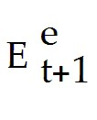 - Et)/Et + xt, where Rt - Rt is the interest rate differential and ( - Et)/Et is the expected change in the exchange rate, what does xt stand for if it potentially is a market efficient difference between the two?
A) market inefficiency
B) risk premium
C) forecast error
D) tracking error
E) excessive volatility
Answer: B
Page Ref: 608-615
Difficulty: Easy

3) Why might a country's savings rate have a high positive correlation to its investment rate?
A) A country's gains from intertemporal trade may have been large.
B) governments' regulation to avoid inflation
C) A country's savings rate and investment rate are generally not positively correlated but rather have negative correlation.
D) governments' regulation to avoid large current account balances
E) A government has not practiced sufficient fiscal regulation.
Answer: D
Page Ref: 608-615
Difficulty: Easy

4) Large differences in interest rates between countries would indicate that
A) the global market is thriving.
B) there is good communication between countries about potential global investment opportunities.
C) there are unrealized gains from trade.
D) the market is in danger of collapse.
E) the supply growth exceeds the aggregate demand.
Answer: C
Page Ref: 608-615
Difficulty: Easy
5) Statistical studies of the relationship between interest rates and later depreciation rates show that
A) the interest difference has been a very bad predictor in the large swings of exchange rates.
B) the interest difference has been an accurate predictor in the large swings of exchange rates.
C) the interest difference has correctly predicted the direction in which exchange rates would change.
D) the interest difference has not yet been studied as a predictor in the large swings of exchange rates.
E) the interest difference is unrelated to the large swings of exchange rates.
Answer: A
Page Ref: 608-615
Difficulty: Easy

6) Which of the following is TRUE about exchange rates?
A) They should not be volatile because they will determine the economic climate.
B) They are generally more volatile than stock prices.
C) They are more volatile than several underlying factors that move them such as money supplies and fiscal variables.
D) They should be volatile because to correct price signals they adjust quickly in response to economic news, but they are generally less volatile than stock prices.
E) They never overreact to economic news.
Answer: D
Page Ref: 608-615
Difficulty: Easy

7) Departures from interest parity
A) can be explained using theories of risk premium.
B) cannot be explained using theories of risk premium.
C) may or may not be able to be explained using theories of risk premium, more research is needed.
D) are completely unrelated to risk premium.
E) occur when risk premium is over calculated.
Answer: C
Page Ref: 608-615
Difficulty: Easy

8) A random walk model can more accurately predict exchange rates as compared to a sophisticated forecast
A) always.
B) for forecasts up to a year away.
C) for forecasts longer than a year away.
D) never.
E) because of the predictability of exchange rates.
Answer: B
Page Ref: 608-615
Difficulty: Easy

9) How well has the international capital market perform?
Answer: International portfolio diversification has increased.
Page Ref: 608-615
Difficulty: Moderate
10) Explain why, according to Feldstein and Horioka, one should expect that domestic investment rates diverge widely from saving rates.
Answer: The decisions of corporations to invest and for households to save are different. Thus globalization means more and different ways to save and invest and increasing the differences between the two ratios.
Page Ref: 608-615
Difficulty: Moderate

11) Explain why large interest rate differences would be strong evidence of unrealized gains from trade.
Answer: The difference between onshore and offshore interest rates on similar assets denominated in the same currency should be small if information about global investment opportunities is transmitted efficiently. Data show that this is the case for the U.S., Germany, Japan and the Netherlands.
Page Ref: 608-615
Difficulty: Moderate

12) Discuss studies based on the interest parity conditions.
Answer: In general, the formula does not hold and is not a good predictor of future devaluations. Even worse, it failed to predict correctly even the direction in which the spot exchange rate would change.
Page Ref: 608-615
Difficulty: Moderate

13) Explain the forecast error, ut+1, in terms of:
(1) Its equation (what it is equal to)
(2) How it is used
(3) Its accuracy
Answer: (Et+1 - Et)/Et - ( - Et)/Et this equation represents actual minus expected depreciation, where ut+1 is the forecast error made in predicting future depreciation.
Under interest parity the equation ((Et+1 - Et)/Et - (Rt - Rt) would also be correct, this equation represents the actual currency depreciation minus the interest difference
Statistical methods have been used to see if the forecast error is predictable through the use of past information. Indeed, a number of researchers have found that ut+1 CAN be predicted.
Page Ref: 608-615
Difficulty: Difficult
14) Does the interest rate parity hold in each of the following cases? In case it does not hold, calculate the risk premium.
A. Rt = 5, 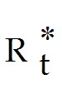 = 3, Et = 5, = 7
B. Rt = 6, = 3, Et = 5, = 7
C. Rt = 7, = 3, Et = 5, = 7
D. Rt = 8, = 3, Et = 5, = 7
E. Rt = 5, = 4, Et = 5, = 7
F. Rt = 5, = 5, Et = 5, = 7
G. Rt = 5, = 6, Et = 5, = 7
H. Rt = 5, = 3, Et = 6, = 7
I. Rt = 5, = 3, Et = 7, = 7
J. Rt = 5, = 3, Et = 8, = 7
K. Rt = 5, = 3, Et = 5, = 8
L. Rt = 5, = 3, Et = 5, = 9
M. Rt = 5, = 3, Et = 5, = 10
Answer:
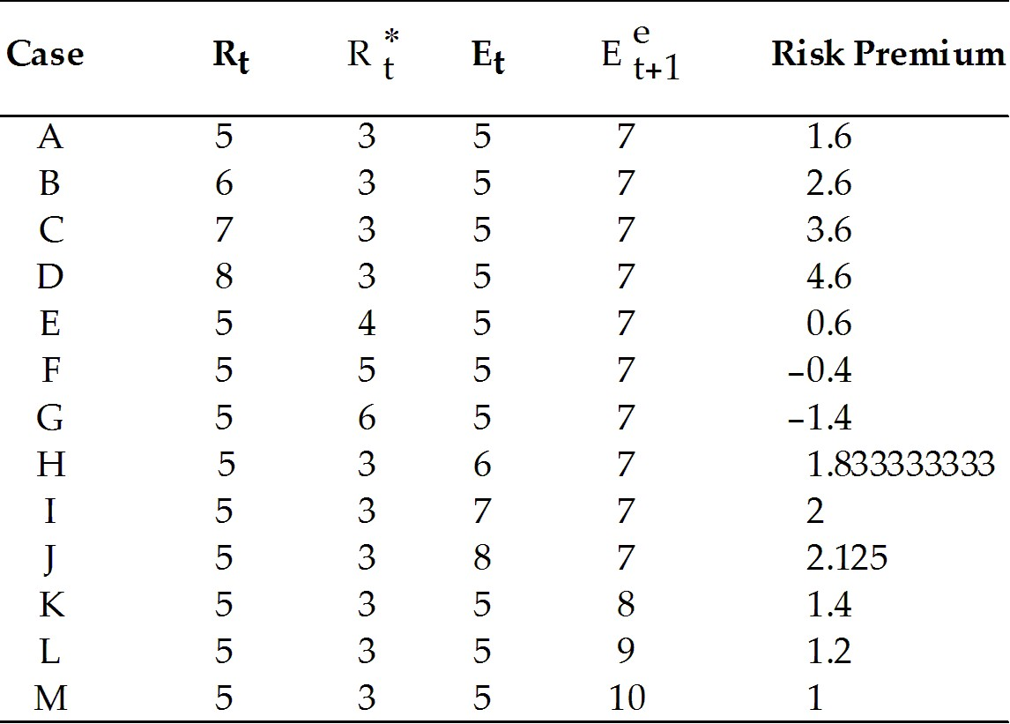
Page Ref: 608-615
Difficulty: Moderate
15) Does the interest rate parity hold in each of the following cases? In case it does not hold, calculate the risk premium.
N. Rt = 8, = 3, Et = 5, = 7
O. Rt = 7, = 4, Et = 6, = 8
P. Rt = 6, = 5, Et = 5, = 7
Q. Rt = 5, = 4, Et = 6, = 8
R. Rt = 8, = 6, Et = 5, = 7
S. Rt = 7, = 5, Et = 6, = 8
T. Rt = 6, = 4, Et = 5, = 7
U. Rt = 5, = 3, Et = 6, = 8
V. Rt = 8, = 5, Et = 6, = 8
W. Rt = 7, = 3, Et = 8, = 9
X. Rt = 6, = 7, Et = 7, = 8
Y. Rt = 5, = 6, Et = 5, = 9
Z. Rt = 4, = 3, Et = 5, = 10
Answer:
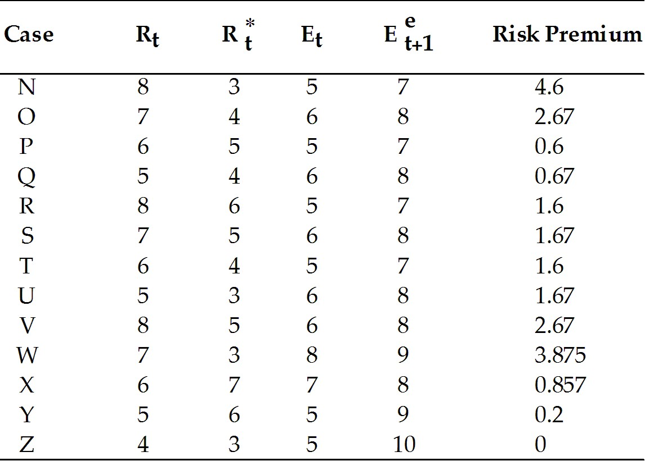
Page Ref: 608-615
Difficulty: Difficult

16) Assume interest parity holds. Calculate for each of the following cases.
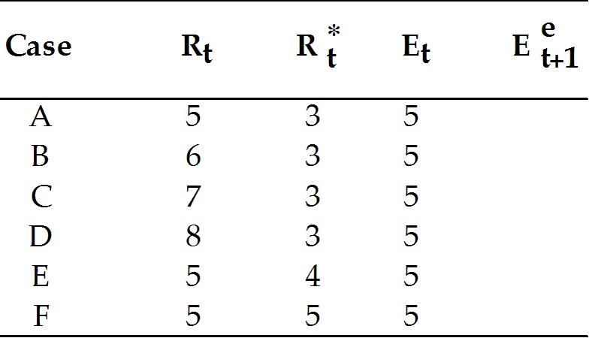
Answer:
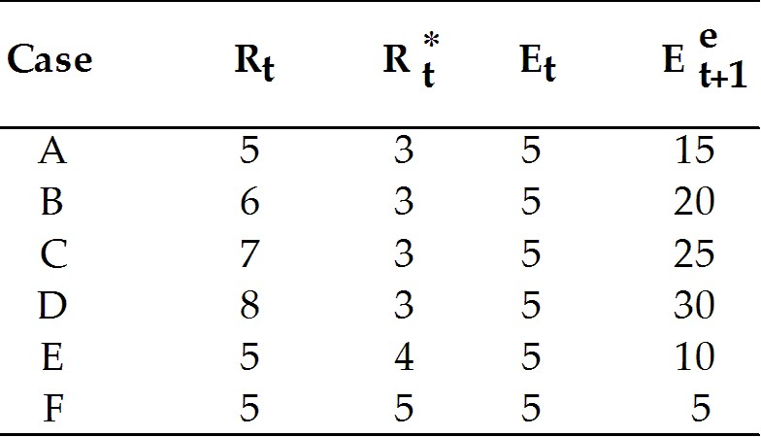
Page Ref: 608-615
Difficulty: Moderate
17) Assume interest parity holds. Calculate for each of the following cases.
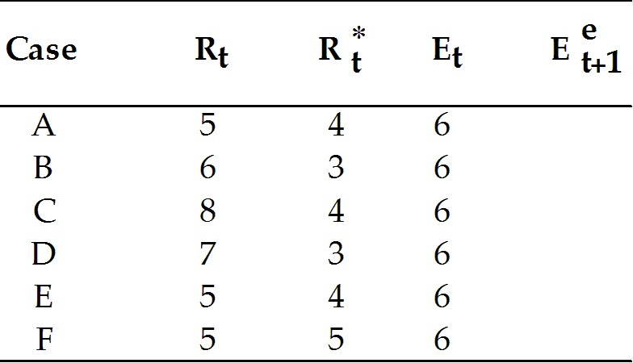
Answer:
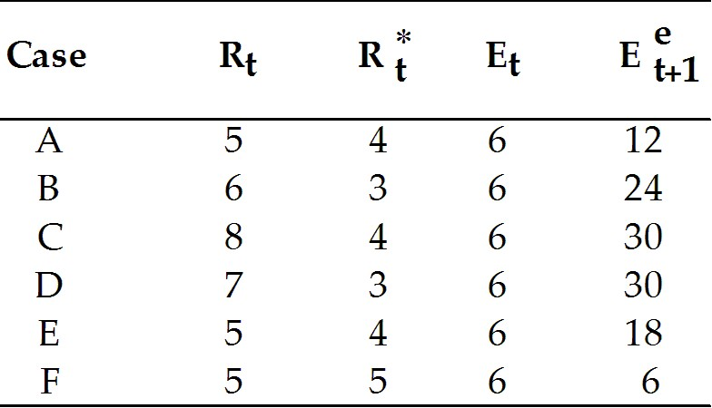

Page Ref: 608-615
Difficulty: Moderate
18) Does the interest rate parity hold in each of the following cases by using the formula
Rt - Rt = (Ee+1 - Et)/Et? In case it does not hold, calculate the risk premium.
1. Rt = 5, = 3, Et = 5, = 17
2. Rt = 6, = 4, Et = 5, = 5
3. Rt = 7, = 5, Et = 5, = 8
4. Rt = 8, = 3, Et = 5, = 15
5. Rt = 5, = 4, Et = 6, = 6
6. Rt = 5, = 5, Et = 3, = 10
7. Rt = 5, = 6, Et = 2, = 8
8. Rt = 5, = 3, Et = 0, = 20
9. Rt = 5, = 9, Et = 7, = 3
10. Rt = 5, = 10, Et = 8, = 7
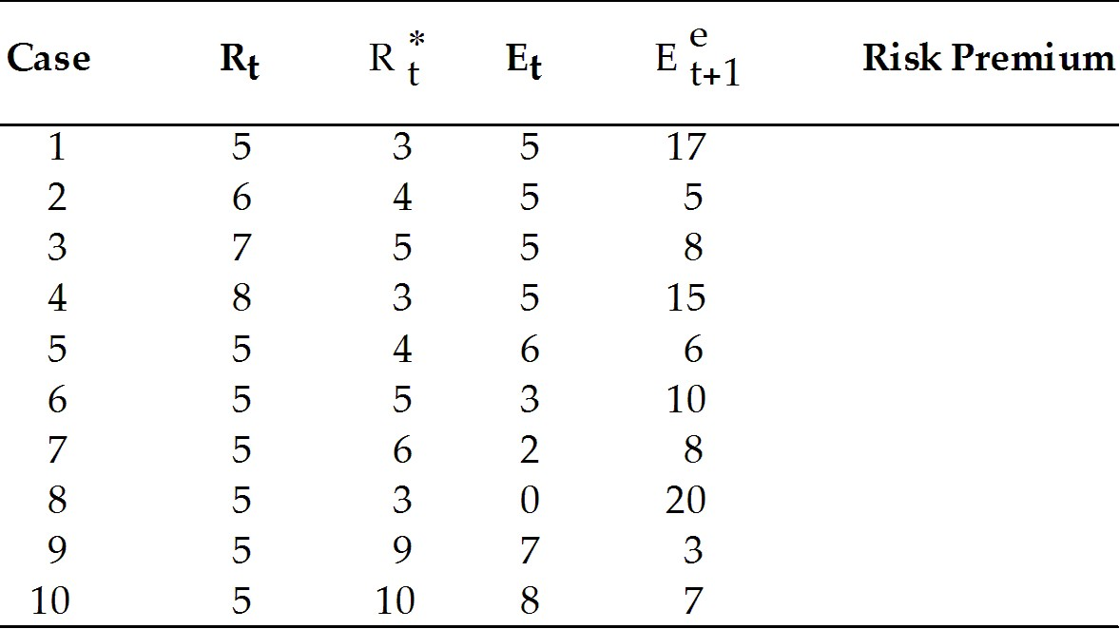

Answer:
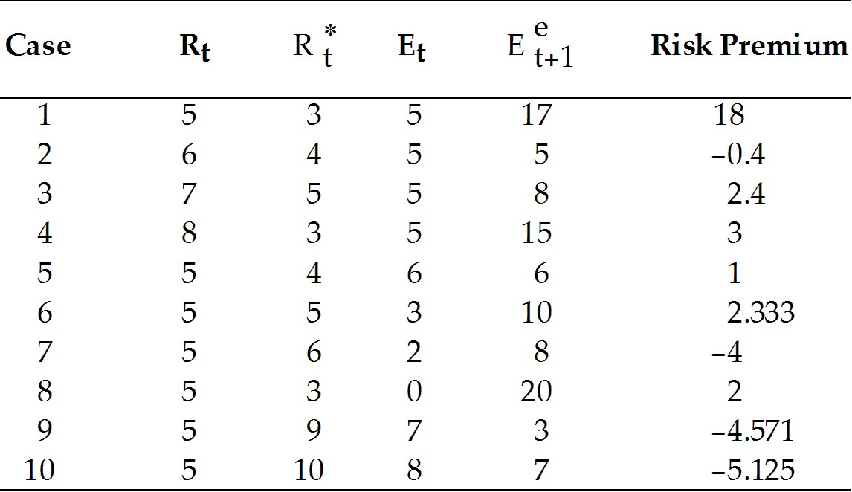
Page Ref: 608-615
Difficulty: Difficult

