International Economics, 10e (Krugman/Obstfeld/Melitz)
Chapter 14 (3) Exchange Rates and the Foreign Exchange Market: An Asset Approach

14.1 Exchange Rates and International Transactions

1) How many dollars would it cost to buy an Edinburgh Woolen Mill sweater costing 50 British pounds if the exchange rate is 1.25 dollars per one British pound?
A) 50 dollars
B) 60 dollars
C) 70 dollars
D) 62.5 dollars
E) 40 British pounds
Answer: D
Page Ref: 342-346
Difficulty: Easy

2) How many dollars would it cost to buy an Edinburgh Woolen Mill sweater costing 50 British pounds if the exchange rate is 1.50 dollars per one British pound?
A) 50 dollars
B) 60 dollars
C) 70 dollars
D) 80 dollars
E) 75 dollars
Answer: E
Page Ref: 342-346
Difficulty: Easy

3) How many dollars would it cost to buy an Edinburgh Woolen Mill sweater costing 50 British pounds if the exchange rate is 1.80 dollars per one British pound?
A) 40 dollars
B) 90 dollars
C) 50 dollars
D) 100 dollars
E) 95 dollars
Answer: B
Page Ref: 342-346
Difficulty: Easy

4) The Japanese currency is called the
A) DM.
B) Yen.
C) Euro.
D) Dollar.
E) Pound.
Answer: B
Page Ref: 342-346
Difficulty: Easy
5) How many British pounds would it cost to buy a pair of American designer jeans costing $45 if the exchange rate is 1.50 dollars per British pound?
A) 10 British pounds
B) 20 British pounds
C) 30 British pounds
D) 35 British pounds
E) 25 British pounds
Answer: C
Page Ref: 342-346
Difficulty: Easy

6) How many British pounds would it cost to buy a pair of American designer jeans costing $45 if the exchange rate is 1.80 dollars per British pound?
A) 10 British pounds
B) 25 British pounds
C) 20 British pounds
D) 30 British pounds
E) 40 British pounds
Answer: B
Page Ref: 342-346
Difficulty: Easy

7) How many British pounds would it cost to buy a pair of American designer jeans costing $45 if the exchange rate is 2.00 dollars per British pound?
A) 22.5 British pounds
B) 32.5 British pounds
C) 12.5 British pounds
D) 40 British pounds
E) 30 British pounds
Answer: A
Page Ref: 342-346
Difficulty: Easy

8) How many British pounds would it cost to buy a pair of American designer jeans costing $45 if the exchange rate is 1.60 dollars per British pound?
A) 38.125 British pounds
B) 28.125 British pounds
C) 48.125 British pounds
D) 58.125 British pounds
E) 18.125 British pounds
Answer: B
Page Ref: 342-346
Difficulty: Easy
9) What is the exchange rate between the dollar and the British pound if a pair of American jeans costs 50 dollars in New York and 100 Pounds in London?
A) 1.5 dollars per British pound
B) 0.5 dollars per British pound
C) 2.5 dollars per British pound
D) 3.5 dollars per British pound
E) 2 dollars per British pound
Answer: B
Page Ref: 342-346
Difficulty: Easy

10) What is the exchange rate between the dollar and the British pound if a pair of American jeans costs 60 dollars in New York and 30 Pounds in London?
A) 1.5 dollars per British pound
B) 0.5 dollars per British pound
C) 2.5 dollars per British pound
D) 3.5 dollars per British pound
E) 2 dollars per British pound
Answer: E
Page Ref: 342-346
Difficulty: Easy

11) When a country's currency depreciates
A) foreigners find that its exports are more expensive, and domestic residents find that imports from abroad are more expensive.
B) foreigners find that its exports are more expensive, and domestic residents find that imports from abroad are cheaper.
C) foreigners find that its exports are cheaper; however, domestic residents are not affected.
D) foreigners are not affected, but domestic residents find that imports from abroad are more expensive.
E) foreigners find that its exports are cheaper and domestic residents find that imports from abroad are more expensive.
Answer: E
Page Ref: 342-346
Difficulty: Easy

12) An appreciation of a country's currency
A) decreases the relative price of its exports and lowers the relative price of its imports.
B) raises the relative price of its exports and raises the relative price of its imports.
C) lowers the relative price of its exports and raises the relative price of its imports.
D) raises the relative price of its exports and lowers the relative price of its imports.
E) raises the relative price of its exports and does not affect the relative price of its imports.
Answer: D
Page Ref: 342-346
Difficulty: Easy
13) Which one of the following statements is the MOST accurate?
A) A depreciation of a country's currency makes its goods cheaper for foreigners.
B) A depreciation of a country's currency makes its goods more expensive for foreigners.
C) A depreciation of a country's currency makes its goods cheaper for its own residents.
D) A depreciation of a country's currency makes its goods cheaper.
E) An appreciation of a country's currency makes its goods more expensive.
Answer: A
Page Ref: 342-346
Difficulty: Easy

14) A(n) ________ of a nation's currency will cause imports to ________ and exports to ________, all other things held constant.
A) depreciation; increase; decrease
B) appreciation; decrease; increase
C) depreciation; decrease; increase
D) appreciation; increase; increase
E) depreciation; decrease; decrease
Answer: C
Page Ref: 342-346
Difficulty: Easy

15) If the goods' money prices do not change, an appreciation of the dollar against the pound
A) makes British sweaters cheaper in terms of American jeans.
B) makes British sweaters more expensive in terms of American jeans.
C) doesn't change the relative price of sweaters and jeans.
D) makes American jeans cheaper in terms of British sweaters.
E) makes British jeans more expensive in Britain.
Answer: A
Page Ref: 342-346
Difficulty: Easy

16) If the goods' money prices do not change, a depreciation of the dollar against the pound
A) makes British sweaters cheaper in terms of American jeans.
B) makes British sweaters more expensive in terms of American jeans.
C) makes American jeans more expensive in terms of British sweaters.
D) doesn't change the relative price of sweaters and jeans.
E) makes British jeans more expensive in Britain.
Answer: B
Page Ref: 342-346
Difficulty: Easy

17) In the year 2012, Shinzo Abe became prime minister of Japan, promising bold policies to improve Japan's economy. What was the focus of his policies and how did they affect Japan's trade position?
Answer: What has been called "Abenomics" involved monetary policies designed to reduce the value of the Japanese Yen relative to other currencies. This resulted in increased exports and reduced imports, strengthening the Japanese economy.
Page Ref: 342-346
Difficulty: Moderate
18) Based on the case study, "Exchange Rates, Auto Prices, and Currency Wars," explain why exchange rates are of critical importance to firms in the automobile industry, and how Japan has benefited from changes in the value of the Yen.
Answer: See the discussion at the beginning of the chapter and in the case. Japan experienced a 15% drop in the value of the yen relative to the U.S. dollar in 2013. This increased Japanese exports of autos while reducing imports from the U.S.
Page Ref: 342-346
Difficulty: Moderate

19) Compute how many dollars it would cost to buy an Edinburgh Woolen Mill sweater costing 50 British pounds for the following exchange rates.

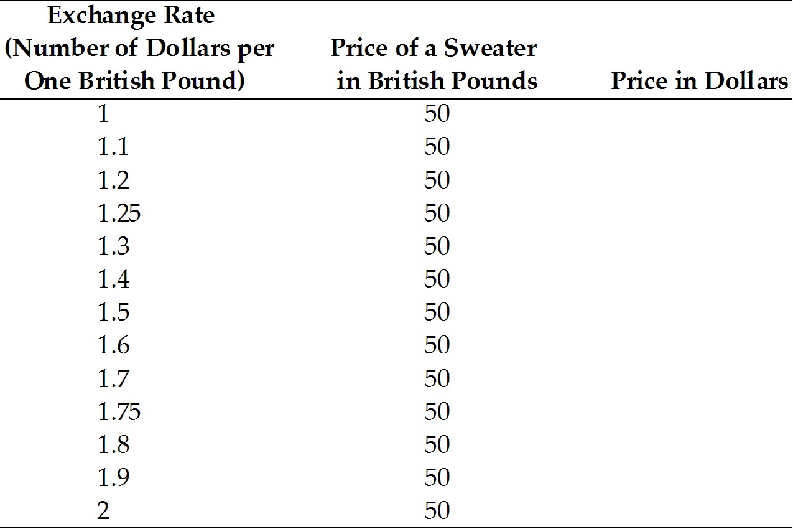
Answer:
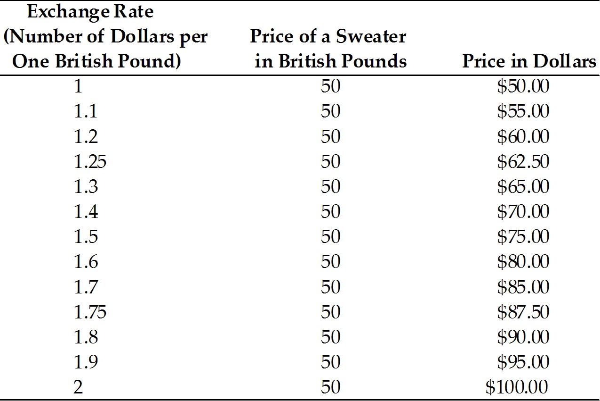
Page Ref: 342-346
Difficulty: Easy
20) Compute how many British pounds it would cost to buy a pair of American designer jeans costing $45.

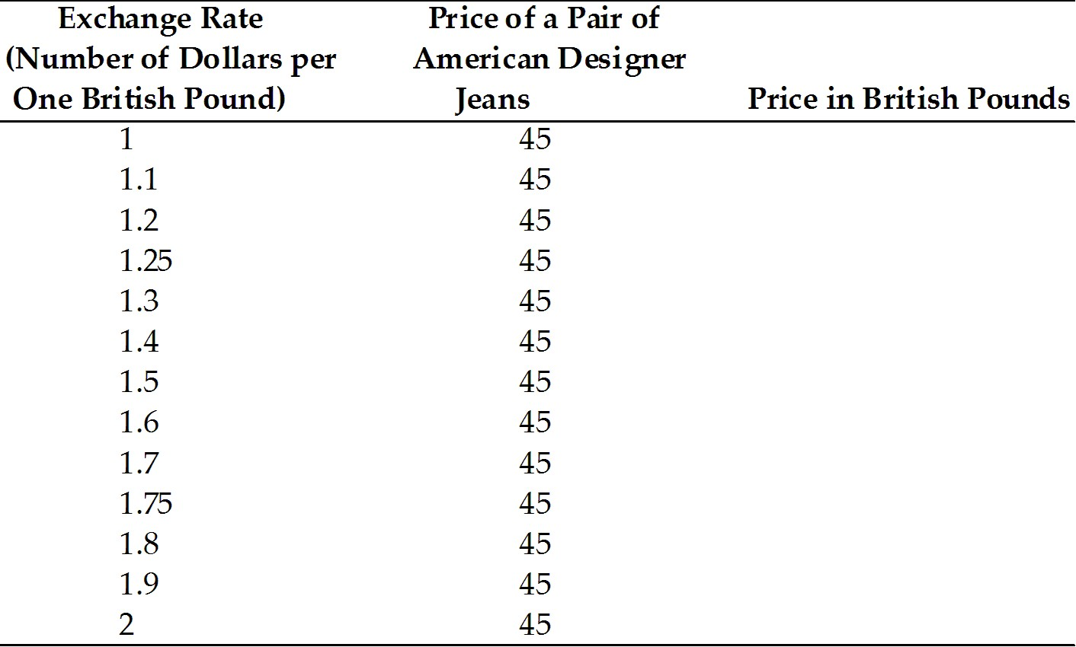
Answer:
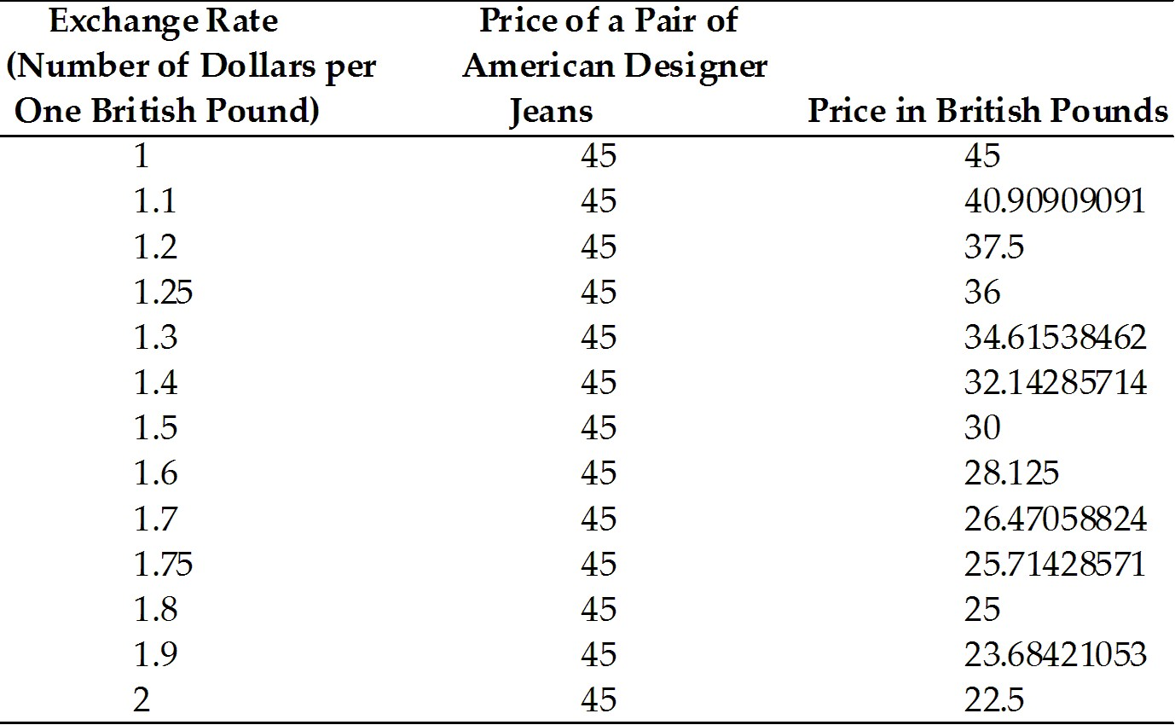
Page Ref: 342-346
Difficulty: Easy
21) Find the exchange rate between the dollar and the British pounds for the following cases.

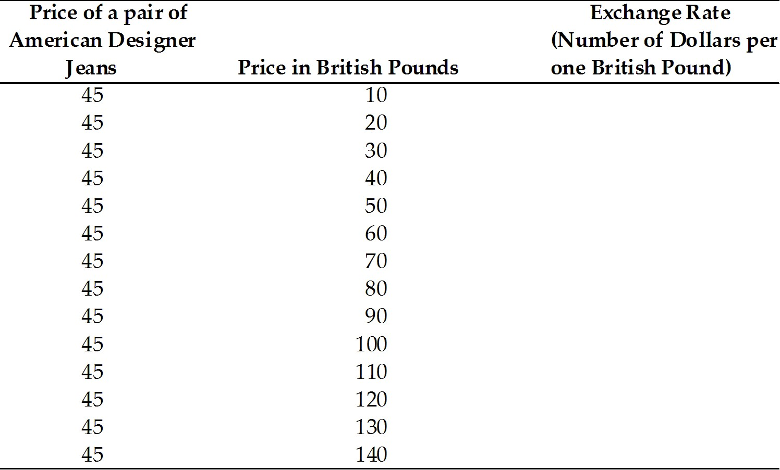
Answer:
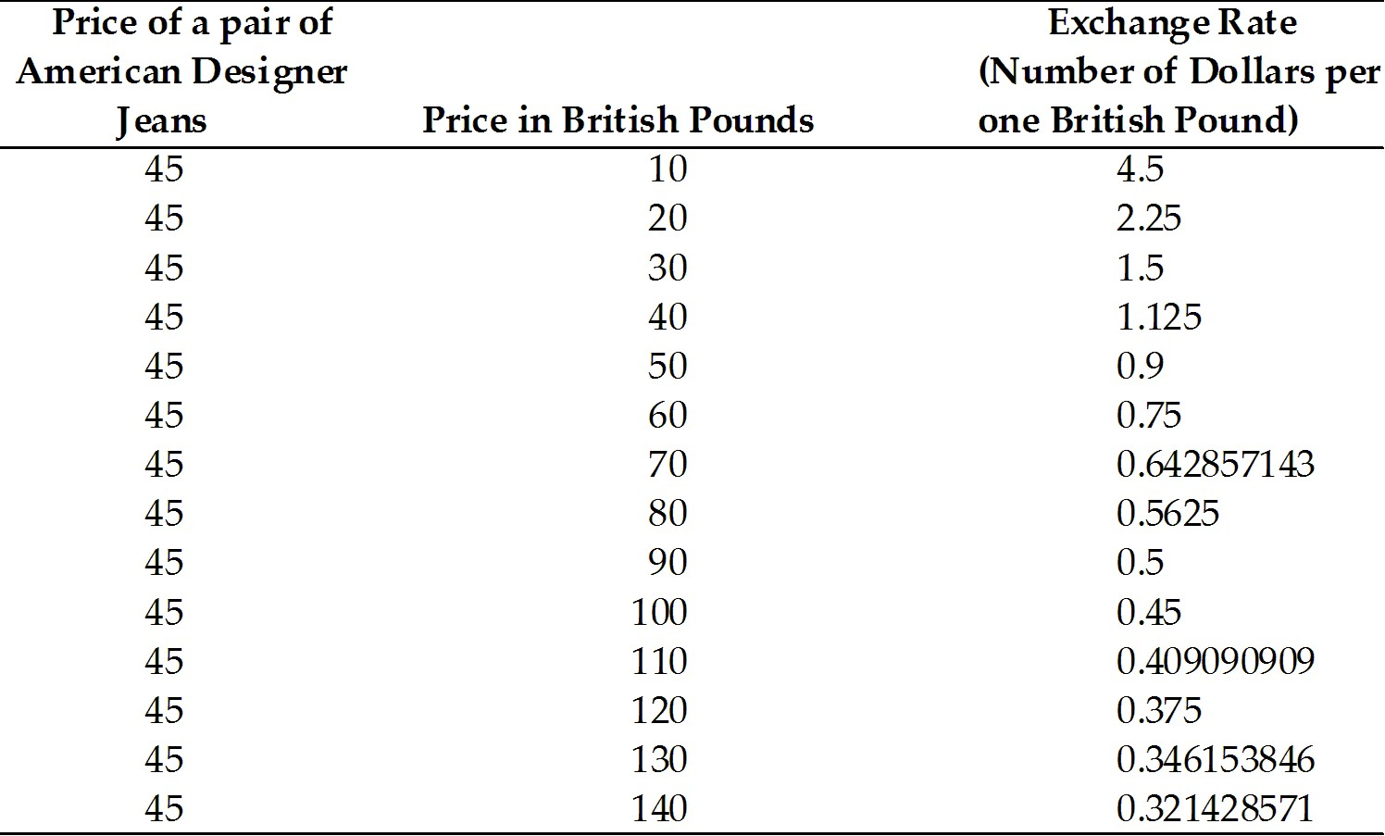
Page Ref: 342-346
Difficulty: Moderate
14.2 The Foreign Exchange Market

1) The largest trading of foreign exchange occurs in
A) New York.
B) London.
C) Tokyo.
D) Frankfurt.
E) Singapore.
Answer: B
Page Ref: 346-352
Difficulty: Easy

2) Which of the following type of funds cater to wealthy individuals, are not bound by government regulations, and are actively traded in foreign exchange markets?
A) pension funds
B) mutual funds
C) hedge funds
D) exchange funds
Answer: C
Page Ref: 346-352
Difficulty: Easy

3) The future date on which the currencies are actually exchanged is called what?
A) the value date
B) the spot exchange date
C) the two-day window
D) the commitment date
E) the forward exchange rate
Answer: A
Page Ref: 346-352
Difficulty: Easy

4) In 2010, about
A) 20 percent of foreign exchange transactions involved exchanges of foreign currencies for U.S. dollars.
B) 10 percent of foreign exchange transactions involved exchanges of foreign currencies for U.S. dollars.
C) 30 percent of foreign exchange transactions involved exchanges of foreign currencies for U.S. dollars.
D) 40 percent of foreign exchange transactions involved exchanges of foreign currencies for U.S. dollars.
E) 85 percent of foreign exchange transactions involved exchanges of foreign currencies for U.S. dollars.
Answer: E
Page Ref: 346-352
Difficulty: Easy
5) Which one of the following statements is the MOST accurate?
A) Spot exchange rates are always higher than forward exchange rates.
B) Spot exchange rates are always lower than forward exchange rates.
C) Spot exchange rates and forward exchanges rates are always equal.
D) Spot exchange rates and forward exchanges rates are equal when the value date and the date of the spot transaction are the same.
E) Spot exchange rates and forward exchange rates never move closely together.
Answer: D
Page Ref: 346-352
Difficulty: Easy

6) Forward and spot exchange rates
A) are necessarily equal.
B) do not move closely together.
C) are always such that the forward exchange rate is higher.
D) move closely together and are equal on the value date.
E) are unrelated to the value date.
Answer: D
Page Ref: 346-352
Difficulty: Easy

7) A foreign exchange swap
A) is a spot sale of a currency.
B) is a forward repurchase of the currency.
C) is a spot sale of a currency combined with a forward repurchase of the currency.
D) is a spot sale of a currency combined with a forward sale of the currency.
E) make up a negligible proportion of all foreign exchange trading.
Answer: C
Page Ref: 346-352
Difficulty: Easy

8) Nondeliverable forward exchange markets in centers such as Hong Kong and Singapore help to circumvent which problem?
A) loss of goods shipped from Hong Kong and Singapore
B) inconvertible currencies cannot be traded in foreign markets
C) lag between the spot exchange date and the value date
D) high travel costs from Asia to "traditional" foreign exchange markets
E) unstable currencies that hold no purchasing power
Answer: B
Page Ref: 346-352
Difficulty: Easy
9) The following is an example of Radio Shack hedging its foreign currency risk
A) needing to pay 9,000 yen per radio to its suppliers in a month, Radio Shack makes a forward-exchange deal to buy yen.
B) needing to pay 9,000 yen per radio to its suppliers in a month, Radio Shack makes a forward-exchange deal to sell yen.
C) needing to pay 9,000 yen per radio to its suppliers in a month, Radio Shack buys yen at a spot-exchange 1 month from now.
D) needing to pay 9,000 yen per radio to its suppliers in a month, Radio Shack sells yen at a spot-exchange 1 month from now.
E) needing to pay 9,000 yen per radio to its suppliers in a month, Radio Shack sells yen in a forward-exchange deal.
Answer: A
Page Ref: 346-352
Difficulty: Easy

10) Which of the following is NOT an example of a financial derivative?
A) forwards
B) bonds
C) swaps
D) futures
E) options
Answer: B
Page Ref: 346-352
Difficulty: Easy

11) Which major actor is at the center of the foreign exchange market?
A) corporations
B) central banks
C) commercial banks
D) non-bank financial institutions
E) individual firms
Answer: C
Page Ref: 346-352
Difficulty: Easy

12) Which of the following is NOT a major actor in the foreign exchange market?
A) corporations
B) central banks
C) commercial banks
D) non-bank financial institutions
E) tourists
Answer: E
Page Ref: 346-352
Difficulty: Easy
13) By April 2010
A) only about 10 percent of foreign exchange trades were against euros.
B) only about 24 percent of foreign exchange trades were against euros.
C) only about 39 percent of foreign exchange trades were against euros.
D) only about 42 percent of foreign exchange trades were against euros.
E) only about 60 percent of foreign exchange trades were against euros.
Answer: C
Page Ref: 346-352
Difficulty: Easy

14) Which of the following statements is TRUE about a vehicle currency?
A) It is widely used to denominate contracts made by parties who reside in the country that issues the vehicle currency.
B) The dollar is sometimes called a vehicle currency because of its pivotal role in many foreign exchange deals.
C) There is much skepticism that the euro will ever evolve into a vehicle currency on par with the dollar.
D) The pound sterling, once second only to the dollar as a key international currency, is beginning to rise in importance.
E) Vehicle currencies include nondeliverable currencies like the renminbi.
Answer: B
Page Ref: 346-352
Difficulty: Easy

15) The action of arbitrage is
A) the process of buying a currency cheap and selling it dear.
B) the process of buying a currency dear and selling it cheap.
C) the process of buying and selling currency at the same price.
D) the process of selling currency at different prices in different markets.
E) the process of buying a currency and holding onto it to take it off the market.
Answer: A
Page Ref: 346-352
Difficulty: Easy

16) Futures contracts differ from forward contracts in that
A) future contracts ensures you will receive a certain amount of foreign currency at a specified future date.
B) future contracts bind you into your end of the deal.
C) future contracts allow you to sell your contract on an organized futures exchange.
D) future contracts are a disadvantage if your views about the future spot exchange rate are to change.
E) futures contracts don't allow you to realize a profit of a loss right away.
Answer: C
Page Ref: 346-352
Difficulty: Easy
17) Exxon Mobil wants to pay 160,000 to a German supplier. They get an exchange rate quotation from its own commercial bank and instructs it to debit their dollar account and pay 160,000 to the supplier's German account. If the exchange rate quoted is $1.2 per euro, how much is debited to Exxon Mobil's account?
A) $160,000
B) $172,000
C) $180,000
D) $192,000
E) $150,000
Answer: D
Page Ref: 346-352
Difficulty: Easy

18) Who are the major participants in the foreign exchange market?
Answer: (1) Commercial banks
(2) Corporations
(3) Nonbank financial institutions
(4) Central banks
Page Ref: 346-352
Difficulty: Easy

19) Explain what is a "vehicle currency." Why is the U.S. dollar considered a vehicle currency?
Answer: A vehicle currency is one that is widely used to denominate international contracts made by parties who do not reside in the country that issues the vehicle currency. Since in 2004, nearly 90 percent of foreign exchange transactions involve exchanges of foreign currencies for U.S. dollars; therefore, it is considered a vehicle currency.
Page Ref: 346-352
Difficulty: Moderate

20) Explain the purpose of the following figure.
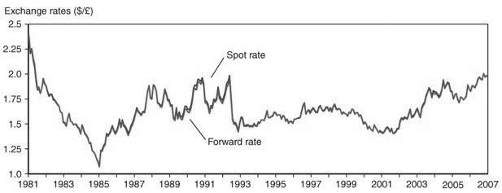
Answer: To show that spot and forward exchange rates are in general close to each other.
Page Ref: 346-352
Difficulty: Easy
21) Explain the purpose of the following figure 14-2 from the text in the context of the interest rates on the dollar and the Japanese Yen between 1980 and 2010.
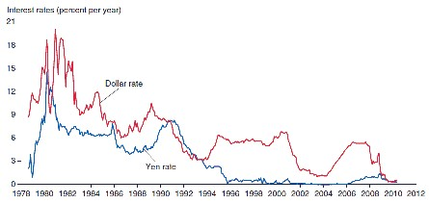
Answer: Since the dollar and the Yen interest rates are not measured in comparable terms, they can move quite differently over time. Except for a period from 1990 to 1993 when the Yen interest rate was higher than the dollar, dollar interest rates have been higher than the Yen, indicating depreciation of the dollar against the Yen.
Page Ref: 346-352
Difficulty: Easy

14.3 The Demand for Foreign Currency Assets

1) What is the expected dollar rate of return on euro deposits if today's exchange rate is $1.10 per euro, next year's expected exchange rate is $1.166 per euro, the dollar interest rate is 10%, and the euro interest rate is 5%?
A) 10%
B) 11%
C) -1%
D) 0%
E) 15%
Answer: B
Page Ref: 352-361
Difficulty: Easy

2) What is the expected dollar rate of return on dollar deposits if today's exchange rate is $1.10 per euro, next year's expected exchange rate is $1.165 per euro, the dollar interest rate is 10%, and the euro interest rate is 5%?
A) 10%
B) 11%
C) -1%
D) 0%
E) 15%
Answer: A
Page Ref: 352-361
Difficulty: Easy
3) What is the expected dollar rate of return on euro deposits if today's exchange rate is $1.167 per euro, next year's expected exchange rate is $1.10 per euro, the dollar interest rate is 10%, and the euro interest rate is 5%?
A) 10%
B) 11%
C) -1%
D) 0%
Answer: C
Page Ref: 352-361
Difficulty: Easy

4) The dollar rate of return on euro deposits is
A) approximately the euro interest rate plus the rate of depreciation of the dollar against the euro.
B) approximately the euro interest rate minus the rate of depreciation of the dollar against the euro.
C) the euro interest rate minus the rate of inflation against the euro.
D) the rate of appreciation of the dollar against the euro.
E) the euro interest rate plus the rate of inflation against the euro.
Answer: A
Page Ref: 352-361
Difficulty: Easy

5) If the dollar interest rate is 10 percent and the euro interest rate is 6 percent, then an investor should
A) invest only in dollars.
B) invest only in euros.
C) be indifferent between dollars and euros.
D) invest only in dollars if the exchange rate is expected to remain constant.
E) invest only in euros if the exchange rate is expected to remain constant.
Answer: D
Page Ref: 352-361
Difficulty: Easy

6) If the dollar interest rate is 4 percent, the euro interest rate is 6 percent, then
A) an investor should invest only in dollars.
B) an investor should invest only in euros.
C) an investor should be indifferent between dollars and euros.
D) invest only in dollars if the exchange rate is expected to remain constant.
E) invest only in euros if the exchange rate is expected to remain constant.
Answer: E
Page Ref: 352-361
Difficulty: Easy
7) If the dollar interest rate is 10 percent, the euro interest rate is 6 percent, then
A) an investor should invest only in dollars if the expected dollar depreciation against the euro is 4 percent.
B) an investor should invest only in euros if the expected dollar depreciation against the euro is 4 percent.
C) an investor should be indifferent between dollars and euros if the expected dollar depreciation against the euro is 4 percent.
D) an investor should invest only in dollars.
E) an investor should invest only in euros.
Answer: C
Page Ref: 352-361
Difficulty: Easy

8) If the dollar interest rate is 10 percent and the euro interest rate is 6 percent, then
A) an investor should invest only in dollars if the expected dollar depreciation against the euro is 8 percent.
B) an investor should invest only in euros if the expected dollar depreciation against the euro is 8 percent.
C) an investor should be indifferent between dollars and euros if the expected dollar depreciation against the euro is 8 percent.
D) an investor should invest only in dollars.
E) an investor should invest only in euros.
Answer: B
Page Ref: 352-361
Difficulty: Easy

9) If the dollar interest rate is 10 percent, the euro interest rate is 12 percent, then
A) an investor should invest only in dollars if the expected dollar appreciation against the euro is 4 percent.
B) an investor should invest only in euros an investor should invest only in dollars if the expected dollar appreciation against the euro is 4 percent.
C) an investor should be indifferent between dollars and euros an investor should invest only in dollars if the expected dollar appreciation against the euro is 4 percent.
D) an investor should invest only in dollars.
E) an investor should invest only in euros.
Answer: A
Page Ref: 352-361
Difficulty: Easy

10) A the beginning of 2012, you pay $100 for a share of stock that then pays you a dividend of $1 at the beginning of 2013. If the stock price rises from $100 to $109 per share over the year, then you have earned an annual rate of return of
A) 5 percent.
B) 1 percent.
C) 9 percent.
D) 4 percent.
E) 10 percent.
Answer: E
Page Ref: 352-361
Difficulty: Easy
11) What are the three factors that affect the demand for foreign currency?
Answer: The three factors that affect the demand for foreign currency are expected return, risk and liquidity.
Page Ref: 352-361
Difficulty: Easy

12) Explain risk and liquidity of assets.
Answer: Risk is the variability an asset contributes to a savers' wealth. An asset's real return can be unpredictable and savers dislike this uncertainty if the return fluctuates widely. Liquidity refers to the ease with which an asset can be sold or exchanged for goods. Cash is the most liquid of assets because it is always acceptable at face value as payment for goods or other assets. Thus, savers consider an asset's liquidity and its expected return and risk in deciding how much of it to hold.
Page Ref: 352-361
Difficulty: Moderate
13) For the following 15 cases, compare the dollar rates of return on dollar and euro deposits.

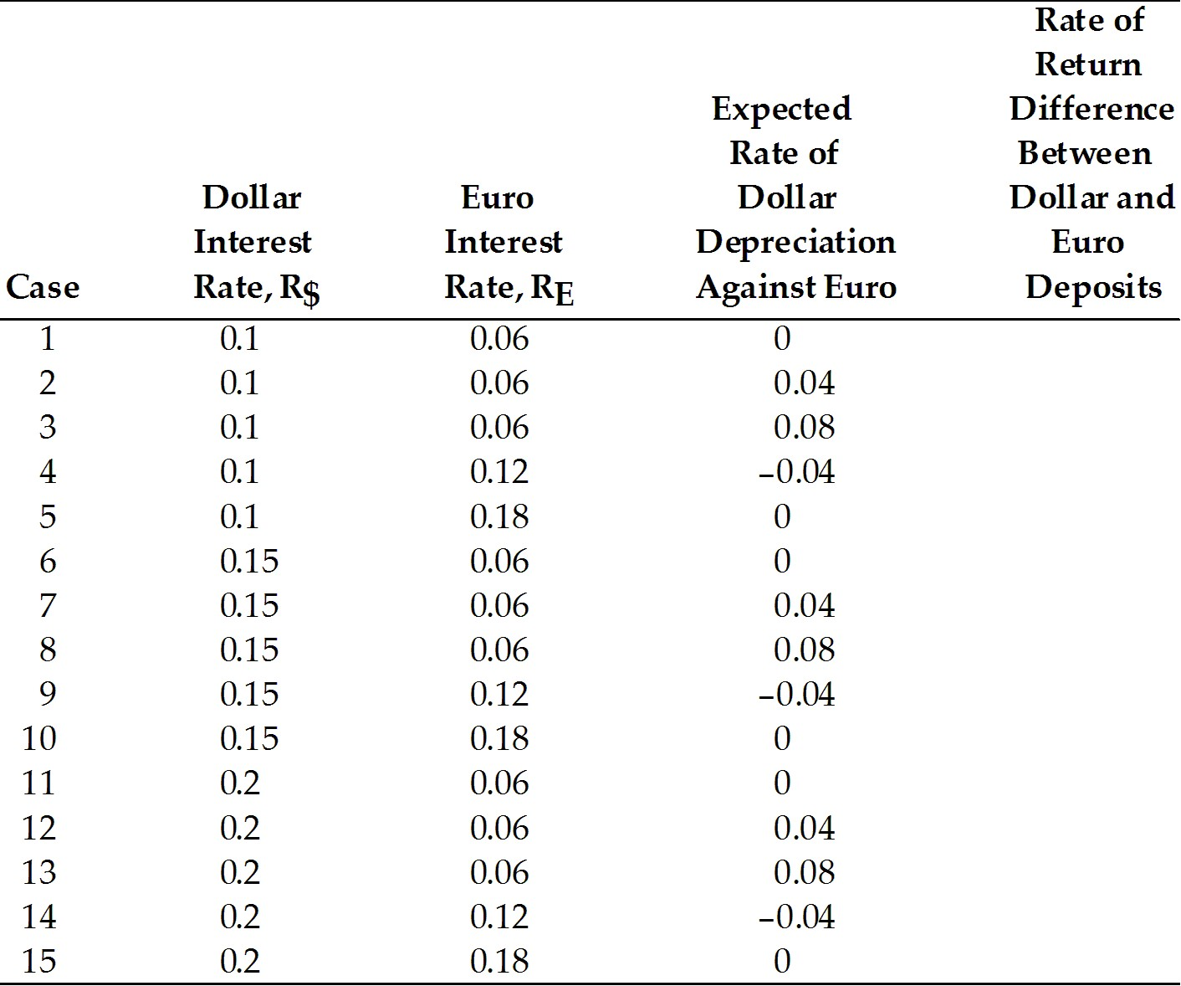
Answer:
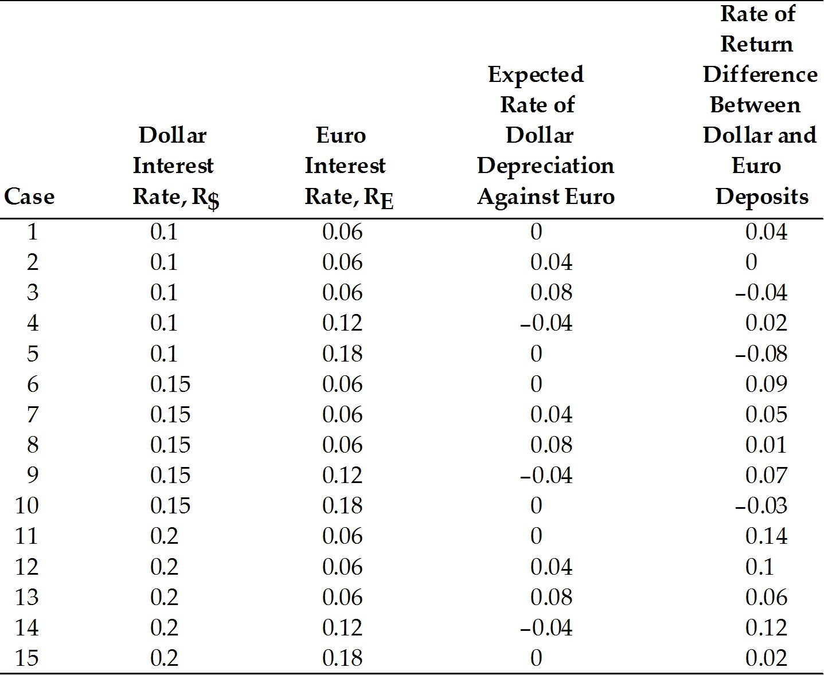
Page Ref: 352-361
Difficulty: Moderate
14) For the table below calculate the EXACT relationship.

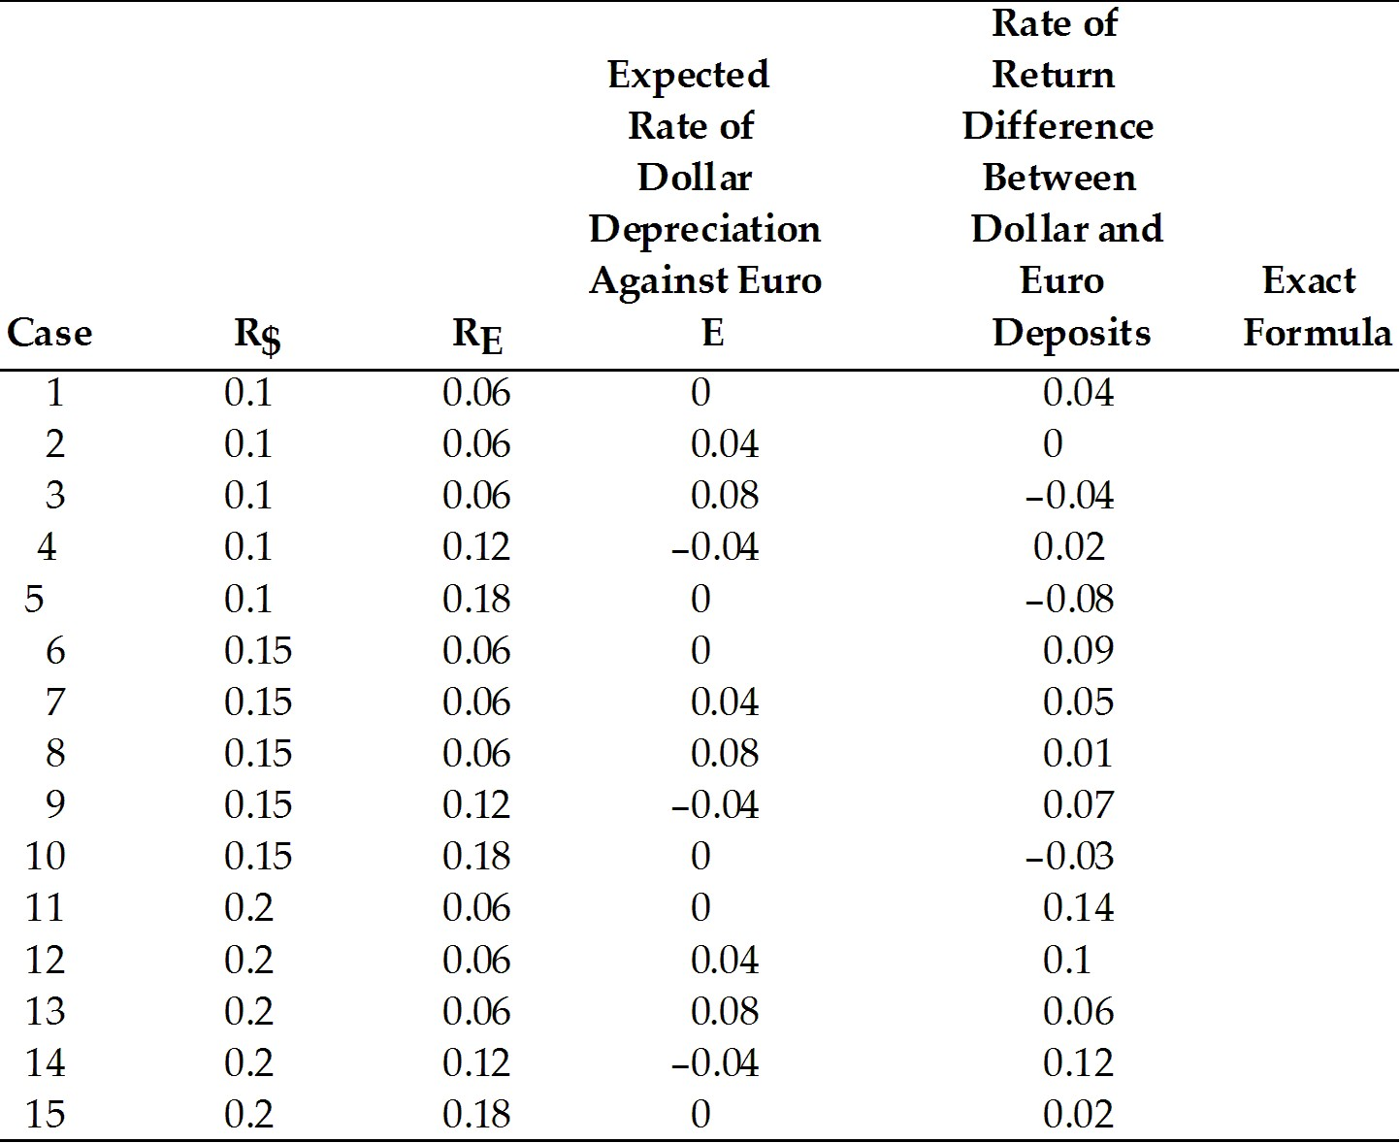
Answer:
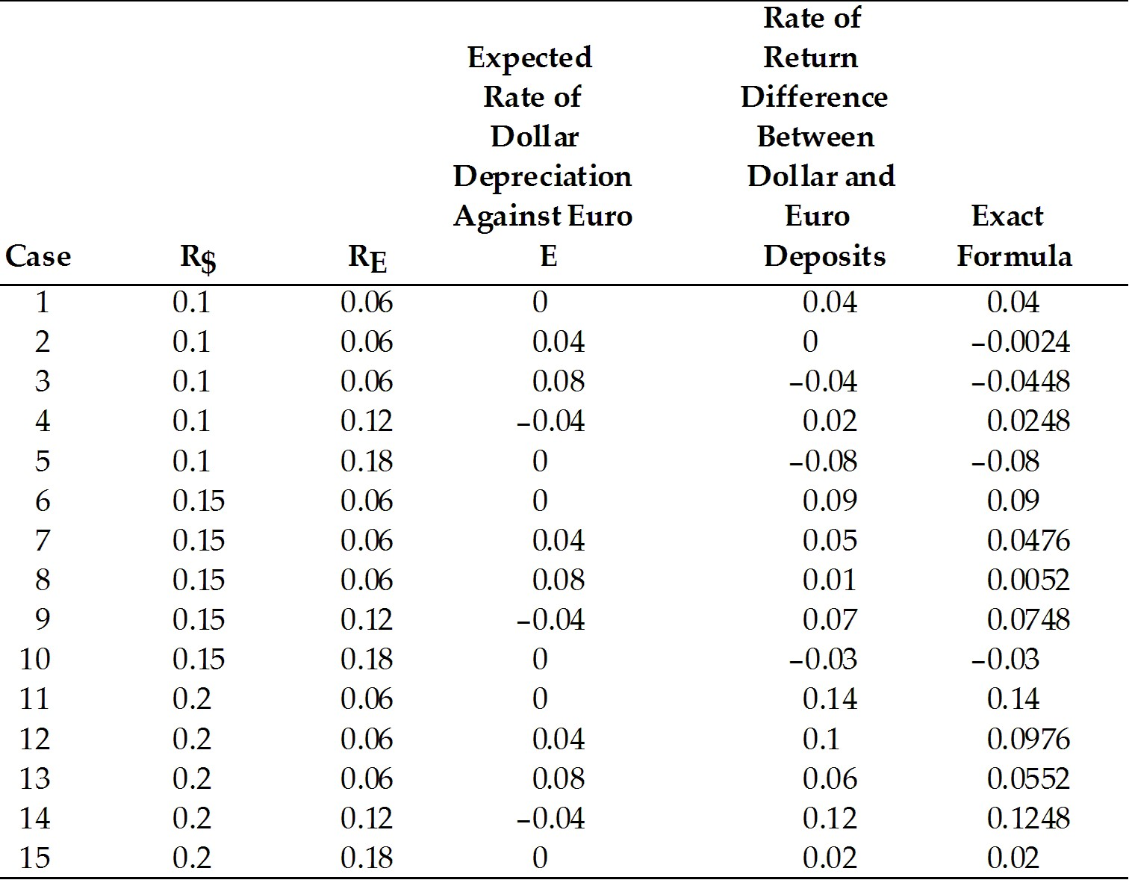
Page Ref: 352-361
Difficulty: Moderate
15) Assume that the euro interest rate is constant at 5 percent, and that the expected exchange rate is 1.05 dollars per one euro. Find the expected dollar return on euro deposits for the following cases.

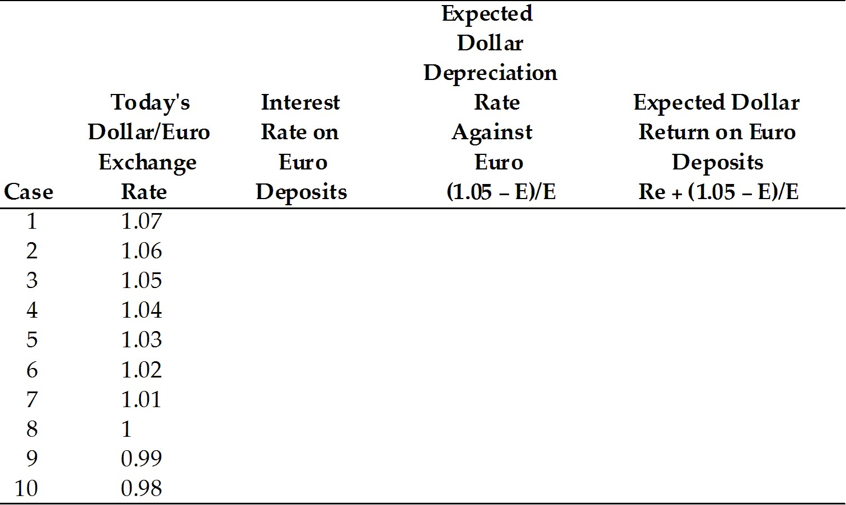
Answer:
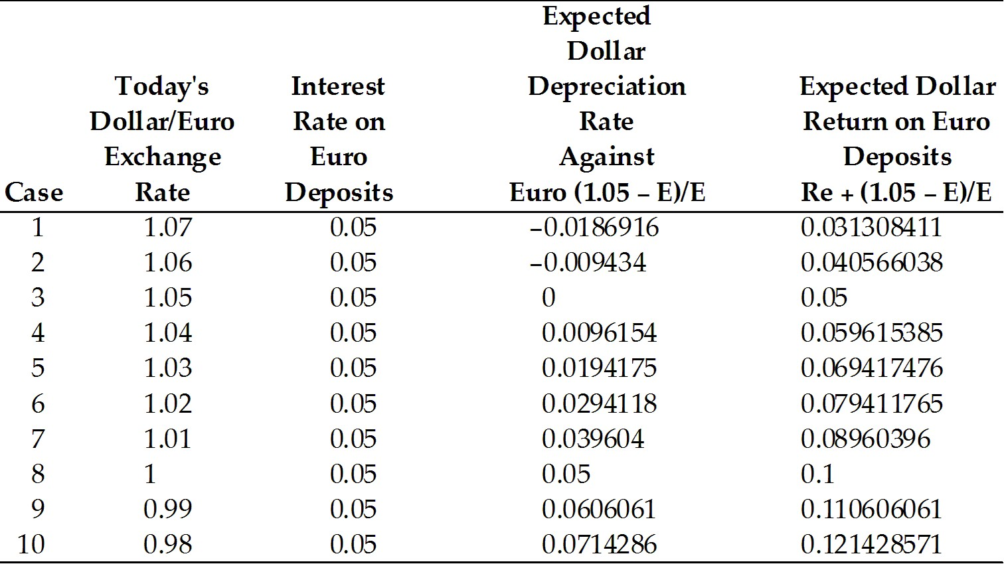
Page Ref: 352-361
Difficulty: Moderate

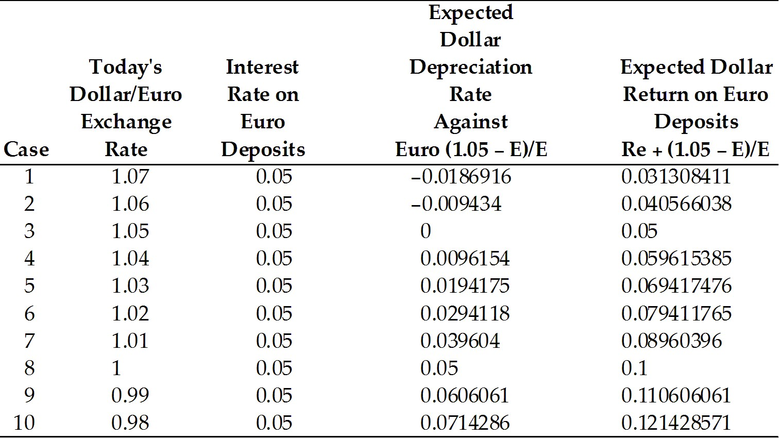

16) Using the data in the table above, plot today's dollar/euro exchange rate against the expected dollar return on euro deposits.
Answer:
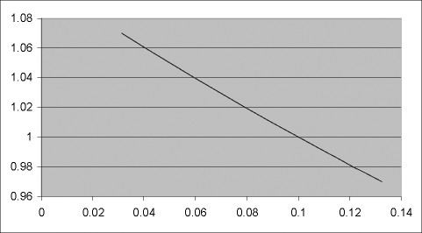
Page Ref: 352-361
Difficulty: Moderate
17) Determine for each, whether the interest parity condition holds or not, if 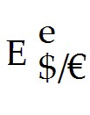 = 1.10

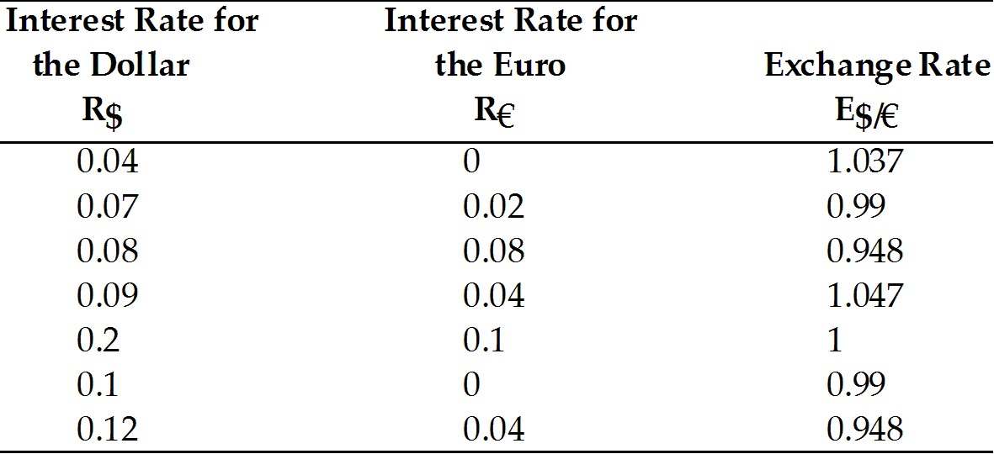
Answer:
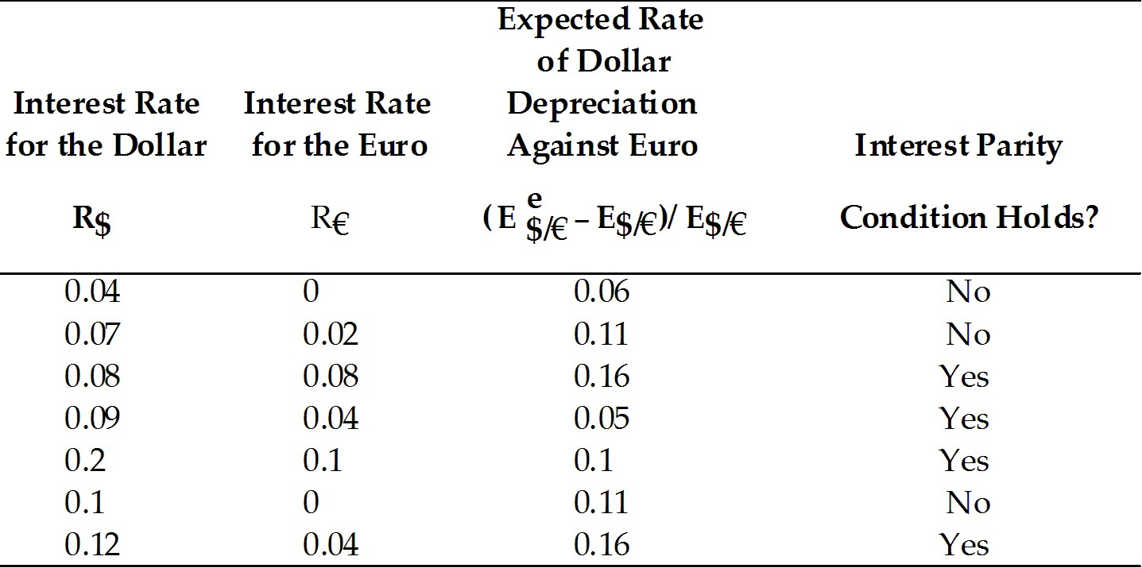

Page Ref: 352-361
Difficulty: Moderate

14.4 Equilibrium in the Foreign Exchange Market

1) Which one of the following statements is the MOST accurate?
A) Since dollar and yen interest rates are measured in comparable terms, they can move quite differently over time.
B) Since dollar and yen interest rates are not measured in comparable terms, they can move quite differently over time.
C) Since dollar and yen interest rates are measured in comparable terms, they move quite the same over time.
D) Since dollar and yen interest rates are measured in comparable terms, they still move quite differently over time.
E) Since dollar and yen interest rates are so similar, they move quite the same way over time.
Answer: B
Page Ref: 361-365
Difficulty: Easy
2) Suppose that the one-year forward price of euros in terms of dollars is equal to $1.113 per euro. Further, assume that the spot exchange rate is $1.05 per euro, and the interest rate on dollar deposits is 10 percent and on euro it is 4 percent. Under these assumptions
A) interest parity does not hold.
B) interest parity does hold.
C) it is hard to tell whether interest parity does or does not hold.
D) Not enough information is given to answer the question.
E) interest parity fluctuates.
Answer: B
Page Ref: 361-365
Difficulty: Easy

3) What is the interest parity condition?
Answer: The condition that the expected returns on deposits of any two currencies are equal when measured in the same currency is called the interest parity condition. It implies that potential holders of foreign currency deposits view them as equally desirable assets, i.e. risk is assumed away.
In notational forms:
R$ = RE + (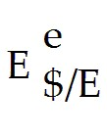 - E$/E)/E$/E
Page Ref: 361-365
Difficulty: Easy

4) Explain why the interest parity condition must hold if the foreign exchange market is in equilibrium.
Answer: The foreign exchange market is in equilibrium when deposits of all currencies offer the same expected rate of return. Potential holders of foreign currency deposits view them all as equally desirable assets. If expected rate of return on any currency deposit is higher or lower than the other, there will exist an excess supply or demand for that currency because one will yield a higher return than the other.
Page Ref: 361-365
Difficulty: Moderate
5) Calculate the interest rate in the United States, if interest parity condition holds, for the following 15 cases.

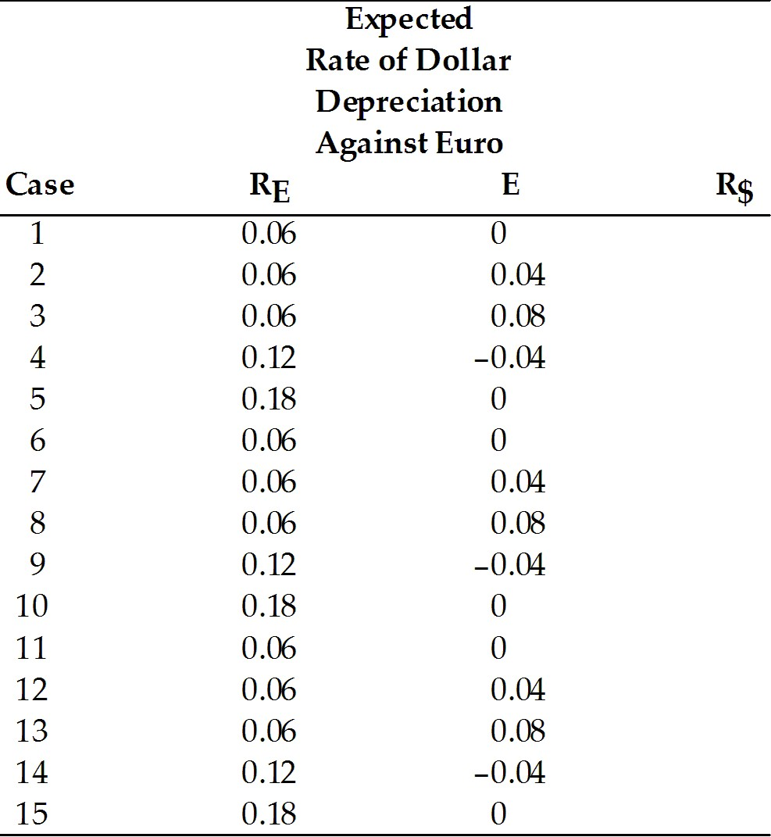
Answer:
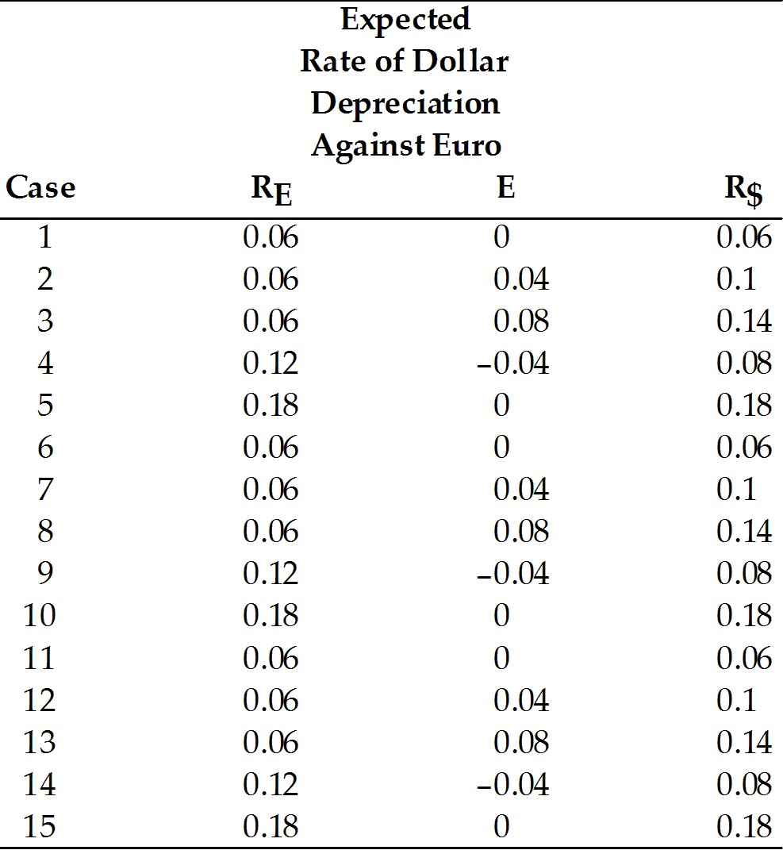
Page Ref: 361-365
Difficulty: Moderate
6) Calculate the interest rate in the euro zone if interest parity condition holds, for the following 15 cases.

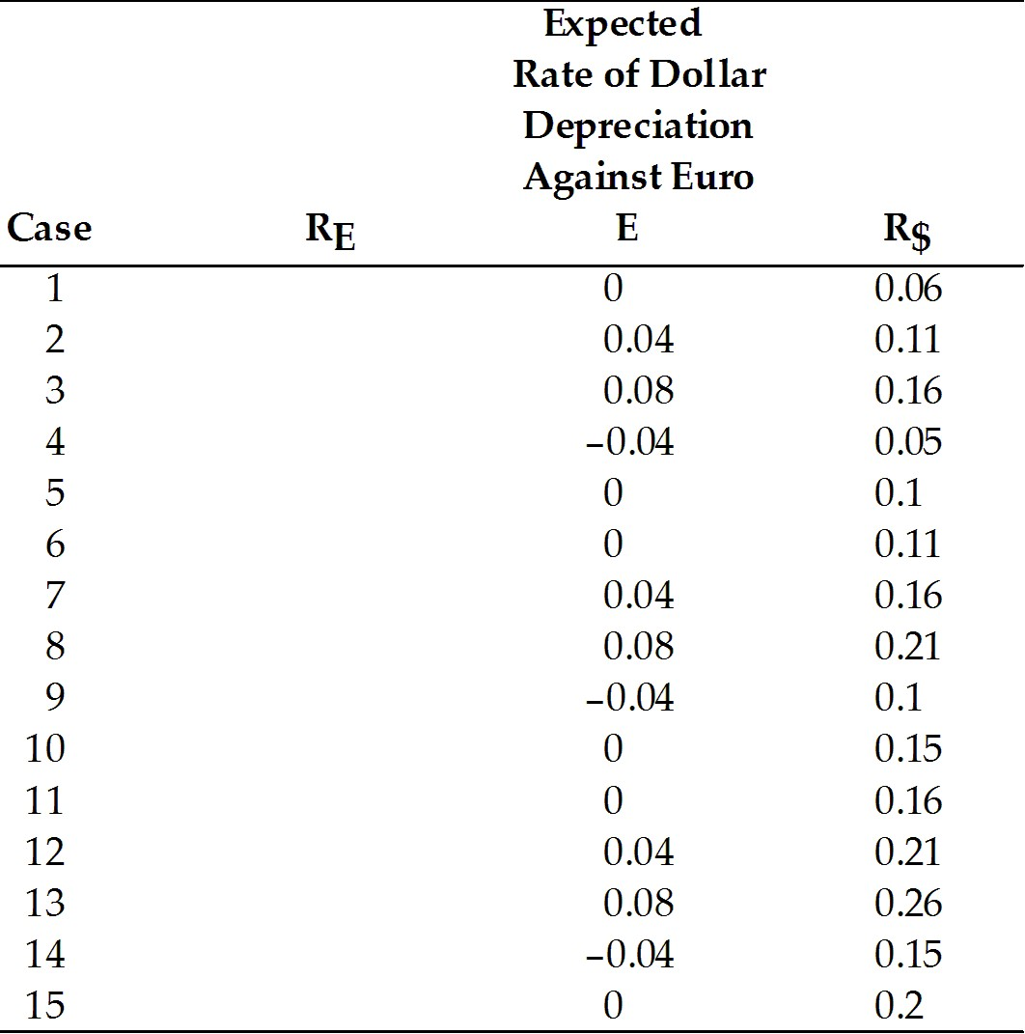
Answer:
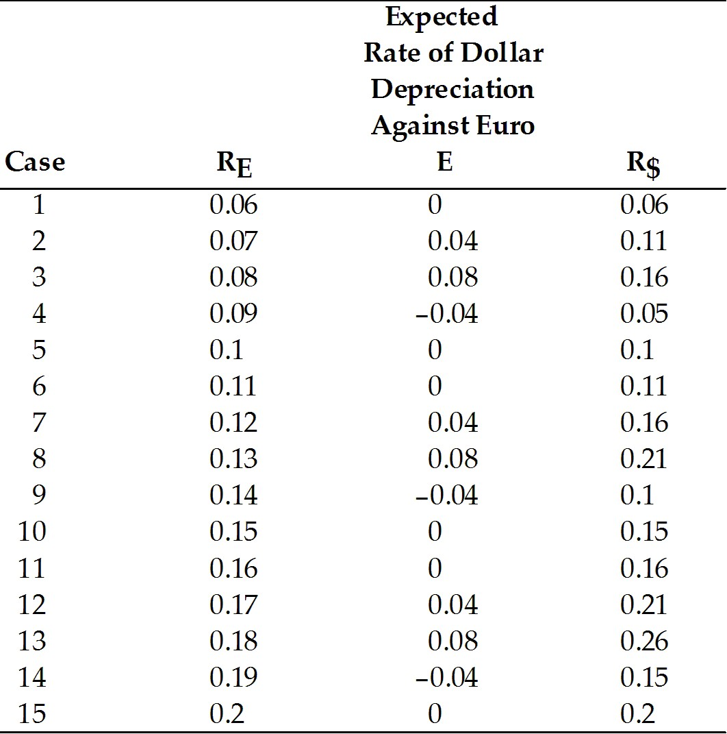
Page Ref: 361-365
Difficulty: Moderate
7) Assume the U.S. interest rate is 10 percent, and the interest rate on euro deposits is 5 percent. For the following exchange rates, find the forward exchange rates.

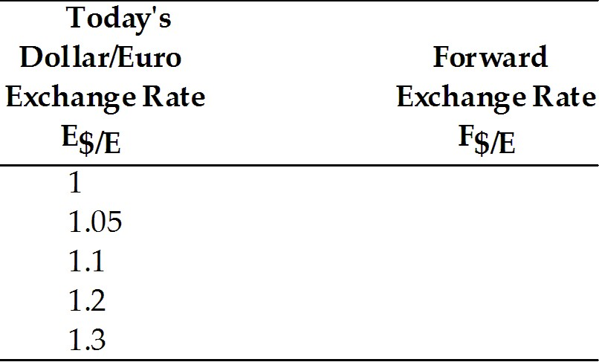
Answer: Using the covered interest rate parity will yield the second column in the table:

F$/E = (R$ - RE) E$/E + E$/E

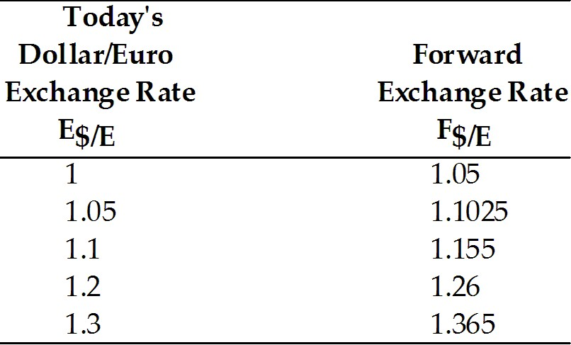

Page Ref: 361-365
Difficulty: Moderate
8) Calculate the Expected Dollar Depreciation Rate against the euro and the expected dollar return on euro deposits if the expected exchange rate is $1.10 per euro.

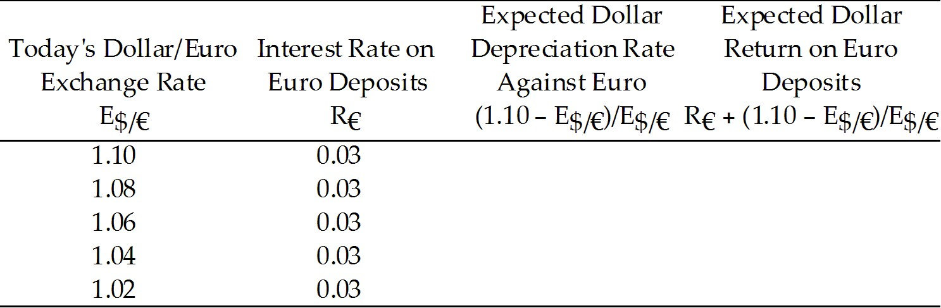
Answer:
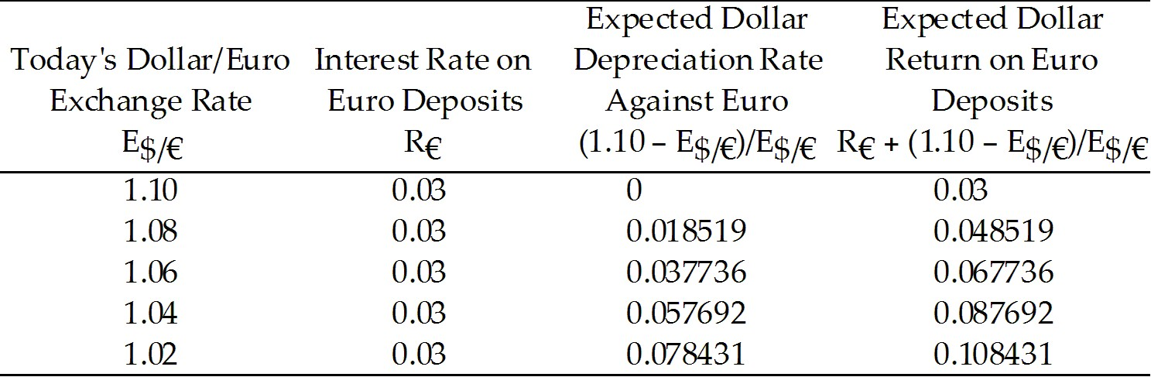
Page Ref: 361-365
Difficulty: Moderate

14.5 Interest Rates, Expectations, and Equilibrium

1) Which one of the following statements is the MOST accurate?
A) A rise in the interest rate offered by dollar deposits causes the dollar to appreciate.
B) A rise in the interest rate offered by dollar deposits causes the dollar to depreciate.
C) A rise in the interest rate offered by dollar deposits does not affect the U.S. dollar.
D) For a given euro interest rate and constant expected exchange rate, a rise in the interest rate offered by dollar deposits causes the dollar to appreciate.
E) A rise in the interest rate offered by the dollar causes the euro to appreciate.
Answer: D
Page Ref: 366-370
Difficulty: Easy
2) Which one of the following statements is the MOST accurate?
A) For a fixed interest rate, a rise in the expected future exchange rate causes a rise in the current exchange rate.
B) For a fixed interest rate, a rise in the expected future exchange rate causes a fall in the current exchange rate.
C) For a fixed interest rate, a rise in the expected future exchange rate does not cause a change in the current exchange rate.
D) For a given dollar interest rate and a constant expected exchange rate, a rise in the interest rate of the euro causes the dollar to depreciate.
E) For a fixed interest rate, a fall in the expected future exchange rate causes a rise in the current exchange rate.
Answer: A
Page Ref: 366-370
Difficulty: Easy
3) Discuss the effects of a rise in the dollar interest rate on the exchange rate.
Answer: There are two effects to consider. A rise in the interest rate offered by dollar deposits combined with a constant expected exchange rate will cause the dollar to appreciate (see Figure 14-5 from the text). However, the expected exchange rate will likely change. As Figure 14-6 from the text shows, if the expected exchange rate increases, the dollar will depreciate.

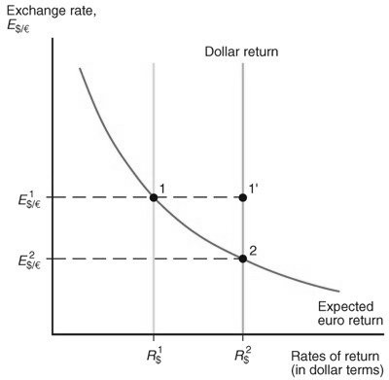
Figure 14-5
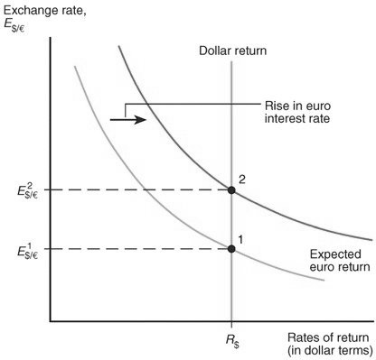
Figure 14-6
Page Ref: 366-370
Difficulty: Moderate
4) Discuss the effects of a rise in the interest rate paid by euro deposits on the exchange rate.
Answer: There are two effects to consider. If we make the unrealistic assumption that the expected exchange rate will not change, then a rise in the interest rate paid by Euro deposits causes the dollar to depreciate. However, if the expected exchange rate were to rise, then the current exchange rate would also rise. (See Figure 14-6 from the text.)

Page Ref: 366-370
Difficulty: Moderate

5) Explain why (holding interest rates constant), a rise in the expected depreciation in a country's currency leads to depreciation of that currency today.
Answer: A rise in the expected depreciation rate of the dollar raises the expected dollar return on euro deposits. Now, there are excess supply of dollar deposits (euro deposits offer higher expected rate of return than do dollar deposits). The dollar must depreciate to remove this excess supply.
Page Ref: 366-370
Difficulty: Moderate
6) Show graphically a drop in the interest rate paid by euro deposits. What is the effect on the dollar?
Answer: A drop in the interest rate from R1$ to R2$ causes the dollar to depreciate from 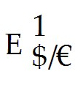 (point 2) to 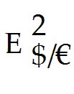 (point 1). (See Figure 14-5 from the text.)
Page Ref: 366-370
Difficulty: Difficult
7) Show graphically a drop in the interest rate offered by dollar deposits, R$, and the effect on the exchange rate, 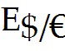.
Answer: A drop in the interest rate paid by euro deposits causes the dollar to appreciate from (point 2) to (point 1). The expected future exchange rate also drops. (See Figure 14-6 from the text.)
Page Ref: 366-370
Difficulty: Difficult

14.6 Appendix to Chapter 14: Forward Exchange Rates and Covered Interest Parity

1) The covered interest rate parity condition can be stated as follows: The interest rate on dollar deposits equals the interest rate on euro deposits ________ the forward ________ on euros against dollars.
A) plus; premium
B) minus; premium
C) plus; discount
D) minus; discount
E) times; premium
Answer: A
Page Ref: 376-378
Difficulty: Easy
2) The covered interest rate parity condition can be stated as follows: The interest rate on dollar deposits equals the interest rate on euro deposits ________ the forward ________ on dollars against euros.
A) plus; discount
B) minus; premium
C) plus; premium
D) minus; discount
E) times; premium
Answer: A
Page Ref: 376-378
Difficulty: Easy

