1) Army WEBCOM (Note: fictional)
Following the President’s announcement of the scheduled deployment of three BCTs to Australia, it has been determined that a secure communications link must be established between the White House, Pentagon, State Department, and the new Australian base. SECDEF and CJCS have tasked Army WEBCOM with the extra responsibility of managing the new communications link.
Currently, 35 Army civilian GS-11 employees in WEBCOM are assigned to U.S. Army Pacific. It is anticipated that 42,800 total work hours per year will be required to maintain the new communications link. Each of the 35 Army civilians currently works full time. For Army civilians, if less than 200 hours of overtime is worked per year, the pay rate for overtime is $60 per hour. If between 200 and 400 hours of overtime is worked per year, the pay rate is $80 per hour of overtime. If more than 400 hours of overtime is worked in one year, the pay rate is $120 per hour of overtime. Contractors may be hired. No vendor quotes are currently available, but from the GSA catalog it has been determined that hourly rates can be estimated to be $88/hr. for this type of contractor labor. Currently, WEBCOM has been placed under a hiring freeze for Army civilians only.
Determine the optimal course of action.
2) In preparation for BRAC, the Army plans to build 20 office buildings (20 acres per office building) for use at Fort Beatrix. Army planners have identified 400 acres of uneven land near Fort Beatrix that it owns, and it has been valued at $45K per acre The cost to the army of constructing the first building is $2.25M, and the cost of constructing each additional building increases by $.25M for each building built due to increasing marginal cost of developing the uneven land (i.e., the second costs $2.5M, the third costs $2.75M, and so on). Alternatively, a contracting company is willing to construct any number of office buildings at a flat rate of $3M each. Determine the optimal courses of action for this scenario (2 correct answers).
3) Forward Operating Base reassignments
Due to the impending drawdown and changing mission requirements, the General Officer overseeing three forward operating bases in Iraq—FOB Ironman, FOB Danger, and FOB Python—has been tasked to come up with 200 soldiers as transportation and logistics specialists within the next six months. However, the GO has been given no new growth mandates. The 200 must be relocated to Baghdad, which is a distance of 100 mi., 200 mi., and 150 mi. from Ironman, Danger, and Python, respectively. Each FOB has provided a list of nonessential personnel available for transfer to Baghdad, along with salary data.
Ironman:
Quantity | Rank | Annual Personnel Cost/person
10 | E-8 | $85,000
15 | E-7 | $70,000
25 | E-6 | $60,000
50 | E-5 | $50,000

Danger:
Quantity | Rank | Annual Personnel Cost/person
10 | E-6 | $60,000
15 | E-5 | $50,000
25 | E-4 | $42,000
50 | E-3 | $38,000

Python:
Quantity | Rank | Annual Personnel Cost/person
150 | E-3 | $38,000
100 | E-2 | $30,000

State the problem, objective, constraints, formulate alternatives, and determine the recommended course of action.
4) USASOC Longbow Apache 2 Modification (fictional)
a) U.S. Army Special Operations Command has scheduled the procurement of seven “Longbow Apache 2” helicopters with a preliminary delivery date of 15 May 2013 (with 95% certainty). Normal procurement cost per Apache is $35M. Each of the new Apaches has been ordered with a classified modification to suit the customized mission requirements of USASOC, at an additional cost over the normal procurement cost for each Apache. All seven customized Apaches are necessary for mission effectiveness. It is known that to achieve the delivery date of 15 May 2013 at the given degree of certainty, the required production rate must far exceed normal capacity, and that this contributes as a cost factor. An analysis of past production performance has determined that the relation between cost and risk can be approximated by r = 0.09c² – 1.24c + 4.32 (for values of c between 3.64 and 10) where r is the risk (expressed as a decimal between 0 and 1) that delivery will miss the deadline, and c is the cost in millions of dollars over the normal procurement cost per Apache. After setting the delivery date at 15 May 2013, USASOC receives an order from SECARMY restricting total procurement costs for the Apache procurement program to $280M. USASOC now needs to determine the optimal value of c. Determine alternatives and the recommended course of action.
b) Due to a last minute change in mission requirements, the original modification has been scrapped in favor of one with a wider range of alternatives. As in part (a), a maximum of $5M per helicopter may be spent on the new modification. The modification can be customized according to two dimensions: survivability and lethality, each scored on a scale between 0 and 1 (1 being the best possible). The associated costs are $5M per point for survivability, and $10M per point for lethality. Suppose that the benefit score may be calculated as L^{x}S^{y}, where L is the score for lethality, S is the score for survivability, x is the weight (as a decimal) placed on lethality, and y is the weight given to survivability. To determine the relative importance of these two dimensions to the mission, you have conducted a survey within three separate populations: infantry, Apache pilots, and USASOC commanders. Among infantry, the consensus is that x = 0.8 and y = 0.2. Among pilots, the consensus is that x = 0.3 y = 0.7. Commanders believe x = 0.6 and y = 0.4. State the problem, objective, constraints, and determine alternatives and the recommended course of action.
5) The Chief of Staff, Army has apportioned $1.2B for the procurement of customized “Longbow Apache 2” helicopters and “Abrams 2” tanks in support of the troop surge in Iraq. Each customized Apache helicopter may be purchased at a flat rate of $60M each. Due to increasing marginal costs of production, the price for the Abrams tank is semi-variable. The first 24 tanks produced can be purchased at a rate of $10M each; the next 40 tanks can be procured at a rate of $12M each every subsequent tank purchased beyond these first 64 will cost $15M each (increasing cost due to onhand excess inventory). [Note: Fictional]
- Analysts at RAND have developed a model that predicts the lethality of helicopter and tank support. In this model, each Apache is assigned 60 points, and each Abrams tank is assigned 11 points, so that the total score for a new procurement would be given by 11x + 60y, where x is the number of Abrams and y is the number of Apaches procured. Determine the allocation of tanks and helicopters that maximizes RAND’s lethality score.
- The Center for Army Analysis has produced a model similar to RAND’s, except each tank is assigned 9 points, and each helicopter is assigned 40 points, so that the total score is found by 9x + 40y. Determine the allocation of tanks and helicopters that maximizes CAA’s lethality score.
- RAND analysts have developed a second model predicting the mobility of helicopter and tank support. In this model, each tank scores 1 point, and each helicopter scores 7 points. Determine the allocation that maximizes RAND’s mobility score.
- CAA analysts have again developed a competing model for mobility: each tank scores 1 point, and each helicopter scores 3 points. Determine the allocation maximizing CAA’s score for mobility.

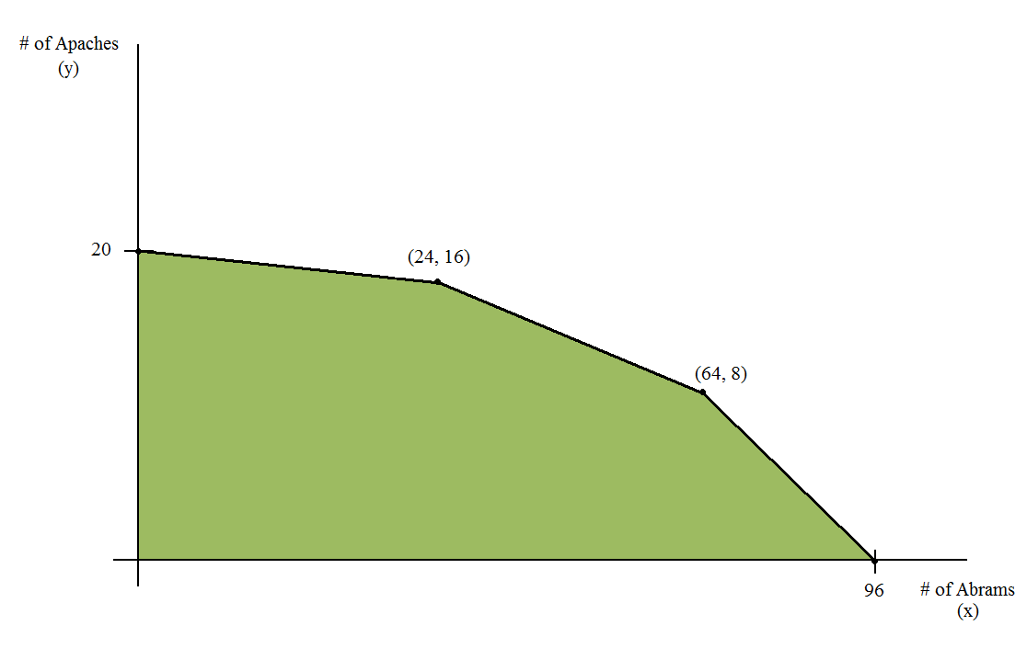
6) U.S. Army Central Command has secured $118M for the procurement of two different models of the “HIMARS 2” multiple rocket launcher—class X and class Y—for deployment to Afghanistan. The class Y HIMARS 2 costs $5M each and weighs 27,000 pounds. The class X HIMARS 2 costs $7M and weighs 12,000 pounds. The class X model is produced using a rare metal: no more than 14 may be procured. All the HIMARS 2 must meet the weight constraint of 405,000 pounds, the maximum payload for a single joint heavy vertical lift sortie.
- The class X model can fire 9 rockets per minute, while the class Y model can fire 6 per minute. If the aim is to maximize the total firepower (rockets per minute) of the entire procurement of HIMARS 2, determine the optimal allocation of class Xs and class Ys.
- Rockets fired from the class X model can cover an area of 10,000 square feet. Rockets fired from the class Y model can cover an area of 30,000 square feet. If the aim is to cover the maximum area, determine the optimal allocation for the procurement.
- If the aim is to simply procure the maximum number of HIMARS rocket launchers, regardless of class, determine the optimal procurement.
7) U.S. Army Special Operations Command maintains a specialized communications link between the Commander, USASOC, the Chief of Staff and Vice Chief of Staff, Army, and Team Leaders in the field during highly sensitive counter-terrorism missions. The link provides video and voice transmissions that are typically delayed by 30 seconds. Currently, $2M per month is spent on operating and maintaining the communications link: mostly consisting of payments to the National Security Agency for “satellite bandwidth.” The NSA has recently launched into orbit a new satellite that promises shorter transmission delays: typically 10 seconds, but with a 20% risk of 20 second delays. The satellite takes advantage of recently developed technology: costs to the Army for the first month are set at $10M, and are projected to decrease based on an 85% learning curve ($10M for the first month, 0.85 x $10M per month for the next two months, 0.85 x 0.85 x $10M per month for the next four months, 0.85^3 x $10M per month for the next eight months, 0.85^4 x $10M per month for the next sixteen months, etc.), though there is a 40% risk that costs will only decrease according to a 90% learning curve.
Because time delay is the overwhelming factor in communications for counter-terrorism operations, Army planners have assigned a 100% benefit weight to signal delay time. The benefit score will be determined by the function $16{\left(\frac{1}{2}\right)}^{\frac{t}{10}}$, where t is the expected time delay in seconds.
- Considering the drawdown in Iraq, it has been proposed that this type of communications link will no longer be needed after one year (twelve months). Supposing that this assumption is correct, determine which COA has the better cost-benefit index.
- Senior leadership has determined that the communications link is an indispensable contingency capability, and that it will need to be maintained for at least the next five years (sixty months). Under these circumstances, determine which COA has the better cost-benefit index.
8) Currently, a contractor provides 12 translators to a SIGINT battalion, each contracted at 1885 hours annually, on a government contract costing $1.7M per year. The battalion commander would like to evaluate the option of insourcing the labor to Army civilians. The total burdened cost per civilian is $85,209 and the annual productivity per worker is estimated at 1740 hours. Determine whether insourcing would be more cost effective than the status quo.
Solution: For insourcing CBAs, the COAs compared should either be normalized by hours of labor, or they should all provide the same number of hours of labor. In this case, hiring 13 civilians would provide the same number of labor hours as 12 contractors. The cost of civilians is therefore 13 x $85,209 = $1.1M per year, so insourcing is the more cost effective COA.

9) OA22 has invited a contracting team to the Pentagon to inspect its centralized HVAC system. Following the inspection, the contractor reported minor damage to the HVAC system, and offers to replace it. Despite the damage, the HVAC system continues to function at the same capacity, although with risk of damage to the building. You assess that in any one year, there is a 15% chance of damage being done. In the event that there is damage, you assess that the average amount of damage will be $200K if occurring within the first year, $300K if occurring during the second year, $400K if occurring during the third year, etc. (increasing by $100K each year). If you decide to replace the HVAC system, the contractor has offered a payment program of $256K for the first year of ownership, $128K for the second year, $64K for the third year, etc. (reduce by 50% each year). The expected life cycle of this HVAC system is 6 years. Alternatively, you may buy the same HVAC system from a separate contractor at a cost of $100K for the first year, and $90K for every subsequent year. Under this special program, the contractor will replace the HVAC system at the end of its life cycle without any additional material cost (operations & maintenance, replacement costs not included). All costs are given in constant FY12 dollars. Perform all steps of the CBA process to support a course of action.

10) The Captain of the Pequod has ordered a cost-benefit analysis to determine the optimal number of rowboats to deploy to pursue a whale sighting. As defined by the Commander, the selection criteria are manpower, stealth, and ease of sustainment, with weights of 0.5, 0.3, and 0.2, respectively. You have been told as a rule of thumb that the total mission cost can be estimated at $2200 for each rowboat involved in the hunt. Each rowboat can transport 15 fishermen.
a) You are asked to assume that the minimum amount of manpower required to pursue the whale is 45 fishermen, and that any additional hands would provide no added benefit in terms of manpower. Determine the optimal COA.
b) Disregard the assumptions in part (a). You have asked the Pequod’s captain to fill out a table of benefit scores for all COAs and selection criteria. On a scale of 1 to 9, 9 is “best” and 1 is “worst” in terms of benefit. You receive the completed table below. Determine the optimal COA.
# of Soldiers | 15 | 30 | 45 | 60 | 75 | 90
Manpower Score | 1 | 2 | 5 | 7 | 8 | 9
Stealth Score | 9 | 8 | 7 | 5 | 3 | 1
Sustainment Score | 9 | 7 | 5 | 4 | 2 | 1

c) After you present your recommendation from part (b), the Captain is surprised at the result. Using algebra or Excel, perform a sensitivity analysis on the weight assigned to manpower, and determine the approximate range of weights for manpower (you may round to the nearest 0.05 for the weight if using Excel) over which the result in part (b) still holds.

