1) Two swimmers, each starting at opposite ends of the English Channel, start swimming toward each other at 0930 GMT. One swimmer swims at a constant rate of 6 miles per hour. The other swims at a constant rate of 5 miles per hour. If they meet precisely at 1200 GMT, how wide is the English Channel (measured from the two starting points)?
a) 25.5 miles
b) 29 miles
c) 27.5 miles
d) 23.5 miles
e) 22 miles
2) Your tractor’s gasoline tank is in the shape of a cylinder that is 1 meter in diameter (cross section pictured below). You measure the gasoline level with a dipstick that is 2 meters long. Note that the point on the dipstick 0.5 meters from one end (0.5 meter mark as pictured) will indicate where the gas tank is half full. Which point on the dipstick marks where the gas tank is one quarter full? (You may assume that the volume of the dipstick is negligible and does not displace any gasoline when submerged).
a) 0.233 m
b) 0.298 m
c) 0.604 m
d) 0.851 m
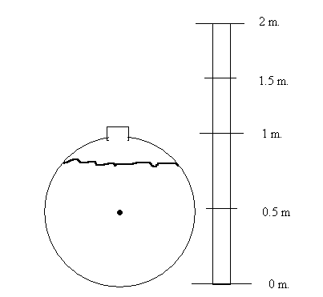
3) The dinner check totaled $150 for a group of three men and five women. The men decided to pay the entire bill after adding a 15% tip. How much does each man pay? (Assume no tax)
a) $52.50
b) $43.50
c) $55.50
d) $48.50
e) $57.50

4) If 3x – 5y = 12 and 2x + 3y = 46, then x + y =
a) 20
b) 23
c) -5
d) -7
e) None of the above

5) There are two cars in front of you waiting for the car wash to open. It takes 15 minutes for each to go through the machine and 10 minutes to be hand dried. If only one employee is working the hand dry station, how long after the car wash opens will it be before you can leave?
a) 50 minutes
b) 75 minutes
c) 25 minutes
d) 15 minutes
e) None of the above
6) Your car's odometer read 213,108 miles when you last filled up and now reads 213,296. You fill up with 8.7 gallons. The tank holds 12 gallons. How many miles per gallon did your car get? (to the nearest tenth)
a) 16.2 mpg
b) 22.5 mpg
c) 15.7 mpg
d) 21.9 mpg
e) None of the above

Answer Key: (1) c; (2) b; (3) e; (4) a; (5) b; (6) e

